Eur-Crete-Seals

Eur-Crete-Seal-Firenzi-[DBAS](http://dbas.sciant.unifi.it/index.html)-UNKNOWN

|  |  |
| --- | --- |
|  | **cms:** Vol. 0 supp. 0 Nr. 0 |
| **chic:** Nr. 185 |
| **place of finding:** -unknown **context:** - unknown context |
| **material:** jasper **shape:** signet |

|  |
| --- |
|  |
| 1 |

**CHIC nr**: 185  
**CMS nr**: Vol 0 Supp 0 Nr 0   
**place of finding**: -unknown (Creta)  
**shape**: signet  
**material**: jasper (hard stones)  
**dimensions mm**: max 10.00 min 10.00 base 0.00 height 0.00  
**bibliography**:   
**place of conservation**: Coll. part. ? (Dessin EM)

**Element A**: X (also CHIC Stiktogram) (geometric patterns) - secondary element  
standing near right up: cross pommée (also CHIC 070)  
- no relation: mallet (also CHIC 056)  
- no relation: sistrum (also CHIC 057)  
standing near left up: ox-head/bucranium (also CHIC 011)  
- no relation: petaloid design  
- no relation: flower (lily)  
**Element B**: cross pommée (also CHIC 070) (geometric patterns) - main element  
standing near left down: X (also CHIC Stiktogram)  
standing near right up: mallet (also CHIC 056)  
- no relation: sistrum (also CHIC 057)  
standing left: ox-head/bucranium (also CHIC 011)  
standing right: petaloid design  
standing above: flower (lily)  
**Element C**: mallet (also CHIC 056) (tools) - main element  
- no relation: X (also CHIC Stiktogram)  
standing near left down: cross pommée (also CHIC 070)  
standing left: sistrum (also CHIC 057)  
- no relation: ox-head/bucranium (also CHIC 011)  
standing below: petaloid design  
standing left: flower (lily)  
**Element D**: sistrum (also CHIC 057) (tools) - main element  
- no relation: X (also CHIC Stiktogram)  
- no relation: cross pommée (also CHIC 070)  
standing right: mallet (also CHIC 056)  
standing below: ox-head/bucranium (also CHIC 011)  
- no relation: petaloid design  
standing below: flower (lily)  
**Element E**: ox-head/bucranium (also CHIC 011) (animals) - main element  
standing near right down: X (also CHIC Stiktogram)  
standing right: cross pommée (also CHIC 070)  
- no relation: mallet (also CHIC 056)  
standing above: sistrum (also CHIC 057)  
- no relation: petaloid design  
standing near right up: flower (lily)  
**Element F**: petaloid design (flora) - secondary element  
- no relation: X (also CHIC Stiktogram)  
standing left: cross pommée (also CHIC 070)  
standing above: mallet (also CHIC 056)  
- no relation: sistrum (also CHIC 057)  
- no relation: ox-head/bucranium (also CHIC 011)  
- no relation: flower (lily)  
**Element G**: flower (lily) (flora) - secondary element  
- no relation: X (also CHIC Stiktogram)  
standing below: cross pommée (also CHIC 070)  
standing right: mallet (also CHIC 056)  
standing above: sistrum (also CHIC 057)  
standing near left down: ox-head/bucranium (also CHIC 011)  
- no relation: petaloid design

|  |  |
| --- | --- |
|  | **[cms:](http://fenzi.dssg.unifi.it/dbas/seal.php?idseal=176" \t "_blank)** [Vol. 0 supp. 0 Nr. 0](http://fenzi.dssg.unifi.it/dbas/seal.php?idseal=176" \t "_blank) |
| **[chic:](http://fenzi.dssg.unifi.it/dbas/seal.php?idseal=176" \t "_blank)** [Nr. 294](http://fenzi.dssg.unifi.it/dbas/seal.php?idseal=176" \t "_blank) |
| **[place of finding:](http://fenzi.dssg.unifi.it/dbas/seal.php?idseal=176" \t "_blank)** [-unknown](http://fenzi.dssg.unifi.it/dbas/seal.php?idseal=176" \t "_blank) **[context:](http://fenzi.dssg.unifi.it/dbas/seal.php?idseal=176" \t "_blank)** [- unknown context](http://fenzi.dssg.unifi.it/dbas/seal.php?idseal=176" \t "_blank) |
| **[material:](http://fenzi.dssg.unifi.it/dbas/seal.php?idseal=176" \t "_blank)** [steatite](http://fenzi.dssg.unifi.it/dbas/seal.php?idseal=176" \t "_blank) **[shape:](http://fenzi.dssg.unifi.it/dbas/seal.php?idseal=176" \t "_blank)** [4-sided prism](http://fenzi.dssg.unifi.it/dbas/seal.php?idseal=176" \t "_blank)  **[CHIC nr](http://fenzi.dssg.unifi.it/dbas/seal.php?idseal=176" \t "_blank)**[: 294](http://fenzi.dssg.unifi.it/dbas/seal.php?idseal=176" \t "_blank) **[CMS nr](http://fenzi.dssg.unifi.it/dbas/seal.php?idseal=176" \t "_blank)**[: Vol 0 Supp 0 Nr 0](http://fenzi.dssg.unifi.it/dbas/seal.php?idseal=176" \t "_blank) **[place of finding](http://fenzi.dssg.unifi.it/dbas/seal.php?idseal=176" \t "_blank)**[: -unknown (Creta)](http://fenzi.dssg.unifi.it/dbas/seal.php?idseal=176" \t "_blank) **[shape](http://fenzi.dssg.unifi.it/dbas/seal.php?idseal=176" \t "_blank)**[: 4-sided prism](http://fenzi.dssg.unifi.it/dbas/seal.php?idseal=176" \t "_blank) **[material](http://fenzi.dssg.unifi.it/dbas/seal.php?idseal=176" \t "_blank)**[: steatite (soft stones)](http://fenzi.dssg.unifi.it/dbas/seal.php?idseal=176" \t "_blank) **[dimensions mm](http://fenzi.dssg.unifi.it/dbas/seal.php?idseal=176" \t "_blank)**[: max 39.50 min 6.90 base 0.00 height 0.00](http://fenzi.dssg.unifi.it/dbas/seal.php?idseal=176" \t "_blank) **[bibliography](http://fenzi.dssg.unifi.it/dbas/seal.php?idseal=176" \t "_blank)**[:](http://fenzi.dssg.unifi.it/dbas/seal.php?idseal=176" \t "_blank) **[place of conservation](http://fenzi.dssg.unifi.it/dbas/seal.php?idseal=176" \t "_blank)**[: Athens, National Museum.](http://fenzi.dssg.unifi.it/dbas/seal.php?idseal=176" \t "_blank) |

[A](http://fenzi.dssg.unifi.it/dbas/seal.php?idseal=176" \t "_blank)

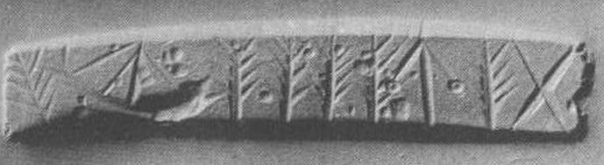

**[R-L:Element A](http://fenzi.dssg.unifi.it/dbas/seal.php?idseal=176" \t "_blank)**[: X (also CHIC Stiktogram) (geometric patterns) - main element  
standing right: tree with ascending branches (also CHIC 025)](http://fenzi.dssg.unifi.it/dbas/seal.php?idseal=176" \t "_blank)

**[Element B](http://fenzi.dssg.unifi.it/dbas/seal.php?idseal=176" \t "_blank)**[: tree with ascending branches (also CHIC 025) (flora) - main element  
standing left: X (also CHIC Stiktogram)  
standing right: arrow (also CHIC 049)](http://fenzi.dssg.unifi.it/dbas/seal.php?idseal=176" \t "_blank)

**[Element C](http://fenzi.dssg.unifi.it/dbas/seal.php?idseal=176" \t "_blank)**[: arrow (also CHIC 049) (tools) - main element](http://fenzi.dssg.unifi.it/dbas/seal.php?idseal=176" \t "_blank)

**[Element D, E, F, G](http://fenzi.dssg.unifi.it/dbas/seal.php?idseal=176" \t "_blank)**[: tree with ascending branches (also CHIC 025) (flora) - main element](http://fenzi.dssg.unifi.it/dbas/seal.php?idseal=176" \t "_blank)

**[Element H](http://fenzi.dssg.unifi.it/dbas/seal.php?idseal=176" \t "_blank)**[: boat (ship) (also CHIC 040) (artefacts) - main element](http://fenzi.dssg.unifi.it/dbas/seal.php?idseal=176" \t "_blank)

**[Element I](http://fenzi.dssg.unifi.it/dbas/seal.php?idseal=176" \t "_blank)**[: tree with ascending branches](http://fenzi.dssg.unifi.it/dbas/seal.php?idseal=176" \t "_blank)

[B](http://fenzi.dssg.unifi.it/dbas/seal.php?idseal=176" \t "_blank)

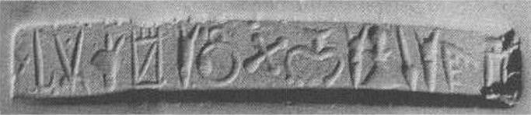

[L-R:](http://fenzi.dssg.unifi.it/dbas/seal.php?idseal=176" \t "_blank) **[Element A](http://fenzi.dssg.unifi.it/dbas/seal.php?idseal=176" \t "_blank)**[: X (also CHIC Stiktogram) (geometric patterns) - main element](http://fenzi.dssg.unifi.it/dbas/seal.php?idseal=176" \t "_blank)

**[Element B](http://fenzi.dssg.unifi.it/dbas/seal.php?idseal=176" \t "_blank)**[: j-hook (also CHIC 059, 302) (geometric patterns) - main element](http://fenzi.dssg.unifi.it/dbas/seal.php?idseal=176" \t "_blank)

**[Element C](http://fenzi.dssg.unifi.it/dbas/seal.php?idseal=176" \t "_blank)**[: sistrum (also CHIC 057) (tools) - main element](http://fenzi.dssg.unifi.it/dbas/seal.php?idseal=176" \t "_blank)

**[Element D](http://fenzi.dssg.unifi.it/dbas/seal.php?idseal=176" \t "_blank)**[: ass-head (also CHIC 014) (animals) - main element](http://fenzi.dssg.unifi.it/dbas/seal.php?idseal=176" \t "_blank)

**[Element E](http://fenzi.dssg.unifi.it/dbas/seal.php?idseal=176" \t "_blank)**[: textiles (also CHIC 041) (tools) - main element](http://fenzi.dssg.unifi.it/dbas/seal.php?idseal=176" \t "_blank)

**[Element F](http://fenzi.dssg.unifi.it/dbas/seal.php?idseal=176" \t "_blank)**[: cuttlefish (also CHIC 019) (animals) - main element](http://fenzi.dssg.unifi.it/dbas/seal.php?idseal=176" \t "_blank)

**[Element G](http://fenzi.dssg.unifi.it/dbas/seal.php?idseal=176" \t "_blank)**[: sieve (also CHIC 047) (tools) - main element](http://fenzi.dssg.unifi.it/dbas/seal.php?idseal=176" \t "_blank)

**[Element H](http://fenzi.dssg.unifi.it/dbas/seal.php?idseal=176" \t "_blank)**[: cross pommée (also CHIC 070) (geometric patterns) - main element](http://fenzi.dssg.unifi.it/dbas/seal.php?idseal=176" \t "_blank)

**[Element I](http://fenzi.dssg.unifi.it/dbas/seal.php?idseal=176" \t "_blank)**[: pronged instrument (also CHIC 092) (tools) - main element](http://fenzi.dssg.unifi.it/dbas/seal.php?idseal=176" \t "_blank)

**[Element J](http://fenzi.dssg.unifi.it/dbas/seal.php?idseal=176" \t "_blank)**[: cuttlefish (also CHIC 019) (animals) - main element](http://fenzi.dssg.unifi.it/dbas/seal.php?idseal=176" \t "_blank)

**[Element K](http://fenzi.dssg.unifi.it/dbas/seal.php?idseal=176" \t "_blank)**[: trowel (also CHIC 044) (tools) - main element](http://fenzi.dssg.unifi.it/dbas/seal.php?idseal=176" \t "_blank)

**[Element L](http://fenzi.dssg.unifi.it/dbas/seal.php?idseal=176" \t "_blank)**[: spear (also CHIC 050) (tools) - main element](http://fenzi.dssg.unifi.it/dbas/seal.php?idseal=176" \t "_blank)

**[Element M](http://fenzi.dssg.unifi.it/dbas/seal.php?idseal=176" \t "_blank)**[: cuttlefish (also CHIC 019) (animals) - main element](http://fenzi.dssg.unifi.it/dbas/seal.php?idseal=176" \t "_blank)

**[Element N](http://fenzi.dssg.unifi.it/dbas/seal.php?idseal=176" \t "_blank)**[: forked branch (also CHIC 028) (flora) - main element](http://fenzi.dssg.unifi.it/dbas/seal.php?idseal=176" \t "_blank)

**[group of signs](http://fenzi.dssg.unifi.it/dbas/seal.php?idseal=176" \t "_blank)**[:  
O M , > 0 D X \ 0 A G 0 5 L](http://fenzi.dssg.unifi.it/dbas/seal.php?idseal=176" \t "_blank)

[C](http://fenzi.dssg.unifi.it/dbas/seal.php?idseal=176" \t "_blank)

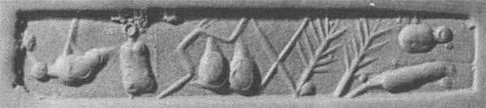

**[Element A](http://fenzi.dssg.unifi.it/dbas/seal.php?idseal=176" \t "_blank)**[: X (also CHIC Stiktogram) (geometric patterns) - main element  
standing above: bird](http://fenzi.dssg.unifi.it/dbas/seal.php?idseal=176" \t "_blank)

**[Element B](http://fenzi.dssg.unifi.it/dbas/seal.php?idseal=176" \t "_blank)**[: bird (animals) - main element  
standing below: X (also CHIC Stiktogram)  
standing left: mallet (also CHIC 056)](http://fenzi.dssg.unifi.it/dbas/seal.php?idseal=176" \t "_blank)

**[Element C](http://fenzi.dssg.unifi.it/dbas/seal.php?idseal=176" \t "_blank)**[: mallet (also CHIC 056) (tools) - main element  
standing right: X (also CHIC Stiktogram)  
standing right: bird  
standing left: zig-zag (also CHIC 061)](http://fenzi.dssg.unifi.it/dbas/seal.php?idseal=176" \t "_blank)

**[Element D](http://fenzi.dssg.unifi.it/dbas/seal.php?idseal=176" \t "_blank)**[: zig-zag (also CHIC 061) (geometric patterns) - main element  
- no relation: X (also CHIC Stiktogram)  
- no relation: bird  
standing right: mallet (also CHIC 056)  
standing left: two jointed ovals (also CHIC 077)](http://fenzi.dssg.unifi.it/dbas/seal.php?idseal=176" \t "_blank)

**[Element E](http://fenzi.dssg.unifi.it/dbas/seal.php?idseal=176" \t "_blank)**[: two jointed ovals (also CHIC 077) (geometric patterns) - main element](http://fenzi.dssg.unifi.it/dbas/seal.php?idseal=176" \t "_blank)

**[Element F](http://fenzi.dssg.unifi.it/dbas/seal.php?idseal=176" \t "_blank)**[: X (also CHIC Stiktogram) (geometric patterns) - main element](http://fenzi.dssg.unifi.it/dbas/seal.php?idseal=176" \t "_blank)

**[Element G](http://fenzi.dssg.unifi.it/dbas/seal.php?idseal=176" \t "_blank)**[: tree with ascending branches (also CHIC 025) (flora) - main element](http://fenzi.dssg.unifi.it/dbas/seal.php?idseal=176" \t "_blank)

**[Element H](http://fenzi.dssg.unifi.it/dbas/seal.php?idseal=176" \t "_blank)**[: tree with ascending branches (also CHIC 025) (flora) - main element](http://fenzi.dssg.unifi.it/dbas/seal.php?idseal=176" \t "_blank)

**[Element I](http://fenzi.dssg.unifi.it/dbas/seal.php?idseal=176" \t "_blank)**[: bird (animals) - main element](http://fenzi.dssg.unifi.it/dbas/seal.php?idseal=176" \t "_blank)

**[Element J](http://fenzi.dssg.unifi.it/dbas/seal.php?idseal=176" \t "_blank)**[: - not clear (unidentifiable) - main element [pine cone? Cat-tail?]](http://fenzi.dssg.unifi.it/dbas/seal.php?idseal=176" \t "_blank)

[D](http://fenzi.dssg.unifi.it/dbas/seal.php?idseal=176" \t "_blank)

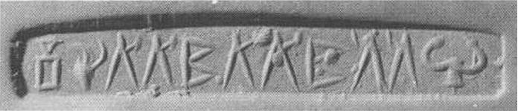

**[Element A](http://fenzi.dssg.unifi.it/dbas/seal.php?idseal=176" \t "_blank)**[: mallet (also CHIC 056) (tools) - main element](http://fenzi.dssg.unifi.it/dbas/seal.php?idseal=176" \t "_blank)

**[Element B](http://fenzi.dssg.unifi.it/dbas/seal.php?idseal=176" \t "_blank)**[: goat's head (also CHIC 016) (animals) - main element](http://fenzi.dssg.unifi.it/dbas/seal.php?idseal=176" \t "_blank)

**[Element C, D](http://fenzi.dssg.unifi.it/dbas/seal.php?idseal=176" \t "_blank)**[: sistrum](http://fenzi.dssg.unifi.it/dbas/seal.php?idseal=176" \t "_blank)

**[Element E](http://fenzi.dssg.unifi.it/dbas/seal.php?idseal=176" \t "_blank)**[: mountains design (also CHIC 034) (geometric patterns) - main element](http://fenzi.dssg.unifi.it/dbas/seal.php?idseal=176" \t "_blank)

**[Element F,G](http://fenzi.dssg.unifi.it/dbas/seal.php?idseal=176" \t "_blank)**[: sistrum](http://fenzi.dssg.unifi.it/dbas/seal.php?idseal=176" \t "_blank)

**[Element K](http://fenzi.dssg.unifi.it/dbas/seal.php?idseal=176" \t "_blank)**[: pronged instrument (also CHIC 092) (tools) - main element [Bull's/Cow's horned head]](http://fenzi.dssg.unifi.it/dbas/seal.php?idseal=176" \t "_blank)

|  |  |
| --- | --- |
|  | **[cms:](http://fenzi.dssg.unifi.it/dbas/seal.php?idseal=182" \t "_blank)** [Vol. 0 supp. 0 Nr. 0](http://fenzi.dssg.unifi.it/dbas/seal.php?idseal=182" \t "_blank) |
| **[chic:](http://fenzi.dssg.unifi.it/dbas/seal.php?idseal=182" \t "_blank)** [Nr. 279](http://fenzi.dssg.unifi.it/dbas/seal.php?idseal=182" \t "_blank) |
| **[place of finding:](http://fenzi.dssg.unifi.it/dbas/seal.php?idseal=182" \t "_blank)** [-unknown](http://fenzi.dssg.unifi.it/dbas/seal.php?idseal=182" \t "_blank) **[context:](http://fenzi.dssg.unifi.it/dbas/seal.php?idseal=182" \t "_blank)** [- unknown context](http://fenzi.dssg.unifi.it/dbas/seal.php?idseal=182" \t "_blank) |
| **[material:](http://fenzi.dssg.unifi.it/dbas/seal.php?idseal=182" \t "_blank)** [steatite](http://fenzi.dssg.unifi.it/dbas/seal.php?idseal=182" \t "_blank) **[shape:](http://fenzi.dssg.unifi.it/dbas/seal.php?idseal=182" \t "_blank)** [4-sided prism](http://fenzi.dssg.unifi.it/dbas/seal.php?idseal=182" \t "_blank) |

[A B](http://fenzi.dssg.unifi.it/dbas/seal.php?idseal=182" \t "_blank)

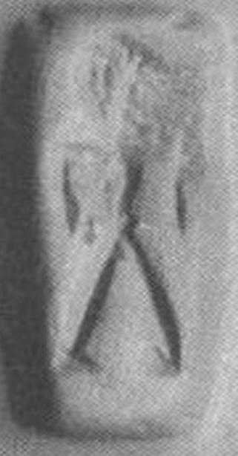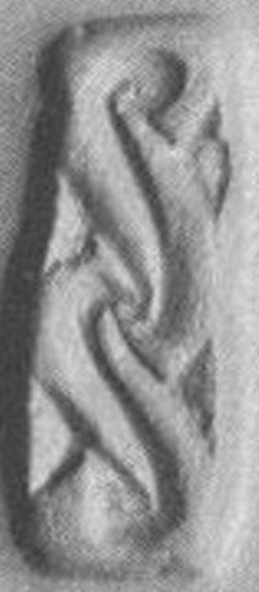

[C D](http://fenzi.dssg.unifi.it/dbas/seal.php?idseal=182" \t "_blank)

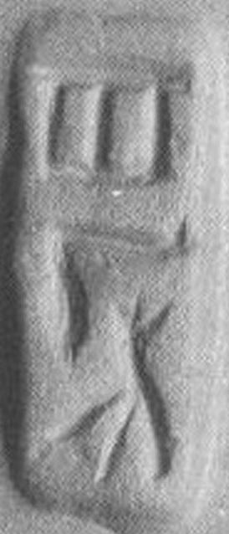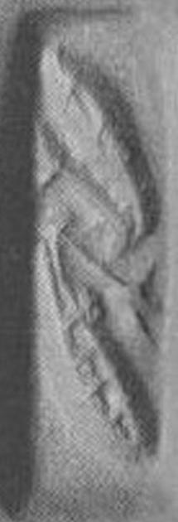

[A:](http://fenzi.dssg.unifi.it/dbas/seal.php?idseal=182" \t "_blank) **[Element A](http://fenzi.dssg.unifi.it/dbas/seal.php?idseal=182" \t "_blank)**[: man (also CHIC 001) (human figures) - main element](http://fenzi.dssg.unifi.it/dbas/seal.php?idseal=182" \t "_blank)

**[B:Element A](http://fenzi.dssg.unifi.it/dbas/seal.php?idseal=182" \t "_blank)**[: s-hook (spiral)](http://fenzi.dssg.unifi.it/dbas/seal.php?idseal=182" \t "_blank)

**[Element B](http://fenzi.dssg.unifi.it/dbas/seal.php?idseal=182" \t "_blank)**[: triangular form](http://fenzi.dssg.unifi.it/dbas/seal.php?idseal=182" \t "_blank)

[C:](http://fenzi.dssg.unifi.it/dbas/seal.php?idseal=182" \t "_blank) **[Element A](http://fenzi.dssg.unifi.it/dbas/seal.php?idseal=182" \t "_blank)**[: gate (also CHIC 038) (artefacts) - main element](http://fenzi.dssg.unifi.it/dbas/seal.php?idseal=182" \t "_blank)

**[Element B](http://fenzi.dssg.unifi.it/dbas/seal.php?idseal=182" \t "_blank)**[: leg (also CHIC 010) (human figures) - main element](http://fenzi.dssg.unifi.it/dbas/seal.php?idseal=182" \t "_blank)

**[Element C](http://fenzi.dssg.unifi.it/dbas/seal.php?idseal=182" \t "_blank)**[: plant with three shoots (also CHIC 031) (flora) - main element](http://fenzi.dssg.unifi.it/dbas/seal.php?idseal=182" \t "_blank)

[D:](http://fenzi.dssg.unifi.it/dbas/seal.php?idseal=182" \t "_blank) **[Element A](http://fenzi.dssg.unifi.it/dbas/seal.php?idseal=182" \t "_blank)**[: petaloid design (flora) - main element  
standing above: flower (lily)  
- no relation: petaloid design](http://fenzi.dssg.unifi.it/dbas/seal.php?idseal=182" \t "_blank)**[Element B](http://fenzi.dssg.unifi.it/dbas/seal.php?idseal=182" \t "_blank)**[: flower (lily) (flora) - main element  
standing below: petaloid design  
standing above: petaloid design](http://fenzi.dssg.unifi.it/dbas/seal.php?idseal=182" \t "_blank)**[Element C](http://fenzi.dssg.unifi.it/dbas/seal.php?idseal=182" \t "_blank)**[: petaloid design (flora) - main element  
- no relation: petaloid design  
standing below: flower (lily)](http://fenzi.dssg.unifi.it/dbas/seal.php?idseal=182" \t "_blank)

|  |  |
| --- | --- |
|  | **[cms:](http://fenzi.dssg.unifi.it/dbas/seal.php?idseal=182" \t "_blank)** [Vol. 0 supp. 0 Nr. 0](http://fenzi.dssg.unifi.it/dbas/seal.php?idseal=182" \t "_blank) |
| **[chic:](http://fenzi.dssg.unifi.it/dbas/seal.php?idseal=182" \t "_blank)** [Nr. 307](http://fenzi.dssg.unifi.it/dbas/seal.php?idseal=182" \t "_blank) |
| **[place of finding:](http://fenzi.dssg.unifi.it/dbas/seal.php?idseal=182" \t "_blank)** [-unknown](http://fenzi.dssg.unifi.it/dbas/seal.php?idseal=182" \t "_blank) **[context:](http://fenzi.dssg.unifi.it/dbas/seal.php?idseal=182" \t "_blank)** [- unknown context](http://fenzi.dssg.unifi.it/dbas/seal.php?idseal=182" \t "_blank) |
| **[material:](http://fenzi.dssg.unifi.it/dbas/seal.php?idseal=182" \t "_blank)** [steatite](http://fenzi.dssg.unifi.it/dbas/seal.php?idseal=182" \t "_blank) **[shape:](http://fenzi.dssg.unifi.it/dbas/seal.php?idseal=182" \t "_blank)** [4-sided prism](http://fenzi.dssg.unifi.it/dbas/seal.php?idseal=182" \t "_blank) |

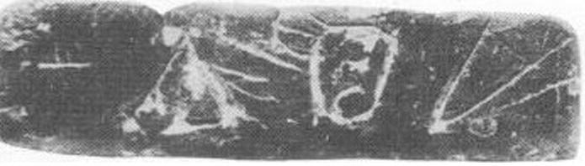

**[Element A](http://fenzi.dssg.unifi.it/dbas/seal.php?idseal=182" \t "_blank)**[: arrow (also CHIC 049) (tools) - main element  
standing left: calf's head (also CHIC 013)  
- no relation: cuttlefish (also CHIC 019)  
- no relation: X (also CHIC Stiktogram)](http://fenzi.dssg.unifi.it/dbas/seal.php?idseal=182" \t "_blank)**[Element B](http://fenzi.dssg.unifi.it/dbas/seal.php?idseal=182" \t "_blank)**[: calf's head (also CHIC 013) (animals) - main element  
standing right: arrow (also CHIC 049)  
standing left: cuttlefish (also CHIC 019)  
- no relation: X (also CHIC Stiktogram)](http://fenzi.dssg.unifi.it/dbas/seal.php?idseal=182" \t "_blank)**[Element C](http://fenzi.dssg.unifi.it/dbas/seal.php?idseal=182" \t "_blank)**[: cuttlefish (also CHIC 019) (animals) - main element  
- no relation: arrow (also CHIC 049)  
standing right: calf's head (also CHIC 013)  
standing left: X (also CHIC Stiktogram)](http://fenzi.dssg.unifi.it/dbas/seal.php?idseal=182" \t "_blank)**[Element D](http://fenzi.dssg.unifi.it/dbas/seal.php?idseal=182" \t "_blank)**[: X (also CHIC Stiktogram) (geometric patterns) - main element  
- no relation: arrow (also CHIC 049)  
- no relation: calf's head (also CHIC 013)  
standing right: cuttlefish (also CHIC 019)](http://fenzi.dssg.unifi.it/dbas/seal.php?idseal=182" \t "_blank)

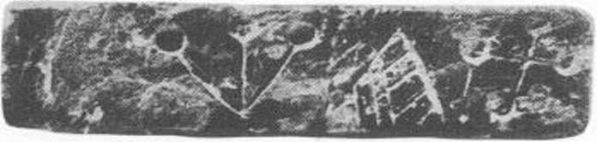

**[Element A](http://fenzi.dssg.unifi.it/dbas/seal.php?idseal=182" \t "_blank)**[: plant with three shoots (also CHIC 031) (flora) - main element  
standing left: forked branch (also CHIC 028)  
- no relation: cross pommée (also CHIC 070)](http://fenzi.dssg.unifi.it/dbas/seal.php?idseal=182" \t "_blank)**[Element B](http://fenzi.dssg.unifi.it/dbas/seal.php?idseal=182" \t "_blank)**[: forked branch (also CHIC 028) (flora) - main element  
standing right: plant with three shoots (also CHIC 031)  
standing left: cross pommée (also CHIC 070)](http://fenzi.dssg.unifi.it/dbas/seal.php?idseal=182" \t "_blank)**[Element C](http://fenzi.dssg.unifi.it/dbas/seal.php?idseal=182" \t "_blank)**[: cross pommée (also CHIC 070) (geometric patterns) - main element  
- no relation: plant with three shoots (also CHIC 031)  
standing right: forked branch (also CHIC 028)](http://fenzi.dssg.unifi.it/dbas/seal.php?idseal=182" \t "_blank)

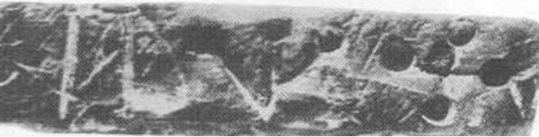

**[Element A](http://fenzi.dssg.unifi.it/dbas/seal.php?idseal=182" \t "_blank)**[: mallet (also CHIC 056) (tools) - main element  
standing left: plant with three shoots (also CHIC 031)  
- no relation: cross pommée (also CHIC 070)](http://fenzi.dssg.unifi.it/dbas/seal.php?idseal=182" \t "_blank)**[Element B](http://fenzi.dssg.unifi.it/dbas/seal.php?idseal=182" \t "_blank)**[: plant with three shoots (also CHIC 031) (flora) - main element  
standing right: mallet (also CHIC 056)  
standing left: cross pommée (also CHIC 070)](http://fenzi.dssg.unifi.it/dbas/seal.php?idseal=182" \t "_blank)**[Element C](http://fenzi.dssg.unifi.it/dbas/seal.php?idseal=182" \t "_blank)**[: cross pommée (also CHIC 070) (geometric patterns) - main element  
- no relation: mallet (also CHIC 056)  
standing right: plant with three shoots (also CHIC 031)](http://fenzi.dssg.unifi.it/dbas/seal.php?idseal=182" \t "_blank)

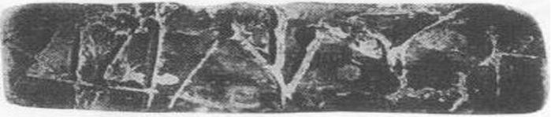

**[Element A](http://fenzi.dssg.unifi.it/dbas/seal.php?idseal=182" \t "_blank)**[: X (also CHIC Stiktogram) (geometric patterns) - main element  
standing left: textiles (also CHIC 041)  
- no relation: plant with three shoots (also CHIC 031)  
- no relation: trowel (also CHIC 044)  
- no relation: X (also CHIC Stiktogram)](http://fenzi.dssg.unifi.it/dbas/seal.php?idseal=182" \t "_blank)**[Element B](http://fenzi.dssg.unifi.it/dbas/seal.php?idseal=182" \t "_blank)**[: textiles (also CHIC 041) (tools) - main element  
standing right: X (also CHIC Stiktogram)  
standing left: plant with three shoots (also CHIC 031)  
- no relation: trowel (also CHIC 044)  
- no relation: X (also CHIC Stiktogram)](http://fenzi.dssg.unifi.it/dbas/seal.php?idseal=182" \t "_blank)**[Element C](http://fenzi.dssg.unifi.it/dbas/seal.php?idseal=182" \t "_blank)**[: plant with three shoots (also CHIC 031) (flora) - main element  
- no relation: X (also CHIC Stiktogram)  
standing right: textiles (also CHIC 041)  
standing left: trowel (also CHIC 044)  
- no relation: X (also CHIC Stiktogram)](http://fenzi.dssg.unifi.it/dbas/seal.php?idseal=182" \t "_blank)**[Element D](http://fenzi.dssg.unifi.it/dbas/seal.php?idseal=182" \t "_blank)**[: trowel (also CHIC 044) (tools) - main element  
- no relation: X (also CHIC Stiktogram)  
- no relation: textiles (also CHIC 041)  
standing right: plant with three shoots (also CHIC 031)  
standing left: X (also CHIC Stiktogram)](http://fenzi.dssg.unifi.it/dbas/seal.php?idseal=182" \t "_blank)**[Element E](http://fenzi.dssg.unifi.it/dbas/seal.php?idseal=182" \t "_blank)**[: X (also CHIC Stiktogram) (geometric patterns) - main element  
- no relation: X (also CHIC Stiktogram)  
- no relation: textiles (also CHIC 041)  
- no relation: plant with three shoots (also CHIC 031)  
standing right: trowel (also CHIC 044)](http://fenzi.dssg.unifi.it/dbas/seal.php?idseal=182" \t "_blank)

|  |  |
| --- | --- |
|  | **[cms:](http://fenzi.dssg.unifi.it/dbas/seal.php?idseal=182" \t "_blank)** [Vol. 2 supp. 2 Nr. 249](http://fenzi.dssg.unifi.it/dbas/seal.php?idseal=182" \t "_blank) |
| **[chic:](http://fenzi.dssg.unifi.it/dbas/seal.php?idseal=182" \t "_blank)** [Nr. 191](http://fenzi.dssg.unifi.it/dbas/seal.php?idseal=182" \t "_blank) |
| **[place of finding:](http://fenzi.dssg.unifi.it/dbas/seal.php?idseal=182" \t "_blank)** [-unknown](http://fenzi.dssg.unifi.it/dbas/seal.php?idseal=182" \t "_blank) **[context:](http://fenzi.dssg.unifi.it/dbas/seal.php?idseal=182" \t "_blank)** [graves](http://fenzi.dssg.unifi.it/dbas/seal.php?idseal=182" \t "_blank) |
| **[material:](http://fenzi.dssg.unifi.it/dbas/seal.php?idseal=182" \t "_blank)** [chalcedony](http://fenzi.dssg.unifi.it/dbas/seal.php?idseal=182" \t "_blank) **[shape:](http://fenzi.dssg.unifi.it/dbas/seal.php?idseal=182" \t "_blank)** |

**[CHIC nr](http://fenzi.dssg.unifi.it/dbas/seal.php?idseal=182" \t "_blank)**[: 169](http://fenzi.dssg.unifi.it/dbas/seal.php?idseal=182" \t "_blank)**[CMS nr](http://fenzi.dssg.unifi.it/dbas/seal.php?idseal=182" \t "_blank)**[: Vol 2 Supp 8 Nr 69](http://fenzi.dssg.unifi.it/dbas/seal.php?idseal=182" \t "_blank)**[place of finding](http://fenzi.dssg.unifi.it/dbas/seal.php?idseal=182" \t "_blank)**[: -unknown (Creta)](http://fenzi.dssg.unifi.it/dbas/seal.php?idseal=182" \t "_blank)**[shape](http://fenzi.dssg.unifi.it/dbas/seal.php?idseal=182" \t "_blank)**[: sealing](http://fenzi.dssg.unifi.it/dbas/seal.php?idseal=182" \t "_blank)**[material](http://fenzi.dssg.unifi.it/dbas/seal.php?idseal=182" \t "_blank)**[: clay (clay)](http://fenzi.dssg.unifi.it/dbas/seal.php?idseal=182" \t "_blank)**[dimensions mm](http://fenzi.dssg.unifi.it/dbas/seal.php?idseal=182" \t "_blank)**[: max 57.00 min 49.50 base 0.00 height 0.00](http://fenzi.dssg.unifi.it/dbas/seal.php?idseal=182" \t "_blank)**[bibliography](http://fenzi.dssg.unifi.it/dbas/seal.php?idseal=182" \t "_blank)**[:](http://fenzi.dssg.unifi.it/dbas/seal.php?idseal=182" \t "_blank)**[place of conservation](http://fenzi.dssg.unifi.it/dbas/seal.php?idseal=182" \t "_blank)**[: Iraklion Museum.](http://fenzi.dssg.unifi.it/dbas/seal.php?idseal=182" \t "_blank)

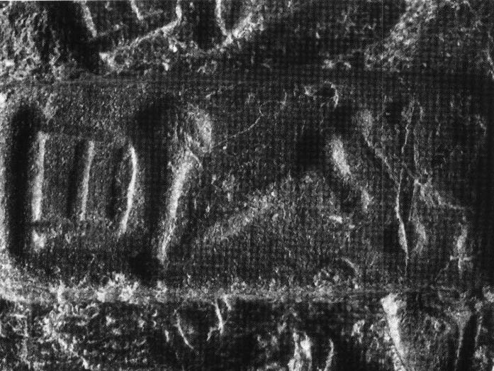

**[Element A](http://fenzi.dssg.unifi.it/dbas/seal.php?idseal=182" \t "_blank)**[: gate (also CHIC 038) (artefacts) - main element  
standing left: leg (also CHIC 010)  
- no relation: plant with three shoots (also CHIC 031)  
- no relation: lunette](http://fenzi.dssg.unifi.it/dbas/seal.php?idseal=182" \t "_blank)**[Element B](http://fenzi.dssg.unifi.it/dbas/seal.php?idseal=182" \t "_blank)**[: leg (also CHIC 010) (human figures) - main element  
standing right: gate (also CHIC 038)  
standing left: plant with three shoots (also CHIC 031)  
standing inside: lunette](http://fenzi.dssg.unifi.it/dbas/seal.php?idseal=182" \t "_blank)**[Element C](http://fenzi.dssg.unifi.it/dbas/seal.php?idseal=182" \t "_blank)**[: plant with three shoots (also CHIC 031) (flora) - main element  
- no relation: gate (also CHIC 038)  
standing right: leg (also CHIC 010)  
- no relation: lunette](http://fenzi.dssg.unifi.it/dbas/seal.php?idseal=182" \t "_blank)**[Element D](http://fenzi.dssg.unifi.it/dbas/seal.php?idseal=182" \t "_blank)**[: lunette (geometric patterns) - secondary element  
- no relation: gate (also CHIC 038)  
standing around: leg (also CHIC 010)  
- no relation: plant with three shoots (also CHIC 031)](http://fenzi.dssg.unifi.it/dbas/seal.php?idseal=182" \t "_blank)

[The D element is composed by five lunettes (three above the B element and two below it).   
This sealing is impressed two (or three?)times on the same object, together with another sealing (CHIC 170).](http://fenzi.dssg.unifi.it/dbas/seal.php?idseal=182" \t "_blank)

|  |  |
| --- | --- |
|  | **[cms:](http://fenzi.dssg.unifi.it/dbas/seal.php?idseal=182" \t "_blank)** [Vol. 2 supp. 8 Nr. 69](http://fenzi.dssg.unifi.it/dbas/seal.php?idseal=182" \t "_blank) |
| **[chic:](http://fenzi.dssg.unifi.it/dbas/seal.php?idseal=182" \t "_blank)** [Nr. 169](http://fenzi.dssg.unifi.it/dbas/seal.php?idseal=182" \t "_blank) |
| **[place of finding:](http://fenzi.dssg.unifi.it/dbas/seal.php?idseal=182" \t "_blank)** [-unknown](http://fenzi.dssg.unifi.it/dbas/seal.php?idseal=182" \t "_blank) **[context:](http://fenzi.dssg.unifi.it/dbas/seal.php?idseal=182" \t "_blank)** [- unknown context](http://fenzi.dssg.unifi.it/dbas/seal.php?idseal=182" \t "_blank) |
| **[material:](http://fenzi.dssg.unifi.it/dbas/seal.php?idseal=182" \t "_blank)** [clay](http://fenzi.dssg.unifi.it/dbas/seal.php?idseal=182" \t "_blank) **[shape:](http://fenzi.dssg.unifi.it/dbas/seal.php?idseal=182" \t "_blank)** [sealing](http://fenzi.dssg.unifi.it/dbas/seal.php?idseal=182" \t "_blank) |

|  |  |
| --- | --- |
|  | **[cms:](http://fenzi.dssg.unifi.it/dbas/seal.php?idseal=182" \t "_blank)** [Vol. 2 supp. 2 Nr. 296](http://fenzi.dssg.unifi.it/dbas/seal.php?idseal=182" \t "_blank) |
| **[chic:](http://fenzi.dssg.unifi.it/dbas/seal.php?idseal=182" \t "_blank)** [Nr. 253](http://fenzi.dssg.unifi.it/dbas/seal.php?idseal=182" \t "_blank) |
| **[place of finding:](http://fenzi.dssg.unifi.it/dbas/seal.php?idseal=182" \t "_blank)** [-unknown](http://fenzi.dssg.unifi.it/dbas/seal.php?idseal=182" \t "_blank) **[context:](http://fenzi.dssg.unifi.it/dbas/seal.php?idseal=182" \t "_blank)** [- unknown context](http://fenzi.dssg.unifi.it/dbas/seal.php?idseal=182" \t "_blank) |
| **[material:](http://fenzi.dssg.unifi.it/dbas/seal.php?idseal=182" \t "_blank)** [onyx](http://fenzi.dssg.unifi.it/dbas/seal.php?idseal=182" \t "_blank) **[shape:](http://fenzi.dssg.unifi.it/dbas/seal.php?idseal=182" \t "_blank)** [3-sided prism](http://fenzi.dssg.unifi.it/dbas/seal.php?idseal=182" \t "_blank) |

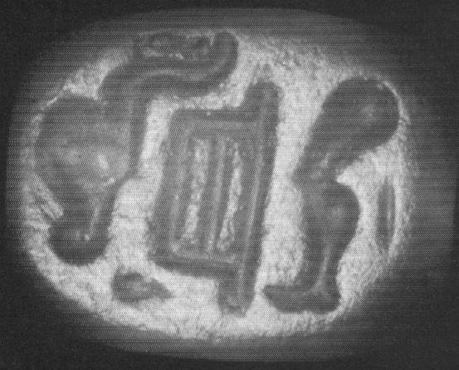

**[CHIC nr](http://fenzi.dssg.unifi.it/dbas/seal.php?idseal=182" \t "_blank)**[: 253](http://fenzi.dssg.unifi.it/dbas/seal.php?idseal=182" \t "_blank)**[CMS nr](http://fenzi.dssg.unifi.it/dbas/seal.php?idseal=182" \t "_blank)**[: Vol 2 Supp 2 Nr 296](http://fenzi.dssg.unifi.it/dbas/seal.php?idseal=182" \t "_blank)**[place of finding](http://fenzi.dssg.unifi.it/dbas/seal.php?idseal=182" \t "_blank)**[: -unknown (Creta)](http://fenzi.dssg.unifi.it/dbas/seal.php?idseal=182" \t "_blank)**[shape](http://fenzi.dssg.unifi.it/dbas/seal.php?idseal=182" \t "_blank)**[: 3-sided prism](http://fenzi.dssg.unifi.it/dbas/seal.php?idseal=182" \t "_blank)**[material](http://fenzi.dssg.unifi.it/dbas/seal.php?idseal=182" \t "_blank)**[: onyx (hard stones)](http://fenzi.dssg.unifi.it/dbas/seal.php?idseal=182" \t "_blank)**[dimensions mm](http://fenzi.dssg.unifi.it/dbas/seal.php?idseal=182" \t "_blank)**[: max 10.00 min 9.00 base 0.00 height 0.00](http://fenzi.dssg.unifi.it/dbas/seal.php?idseal=182" \t "_blank)**[bibliography](http://fenzi.dssg.unifi.it/dbas/seal.php?idseal=182" \t "_blank)**[:](http://fenzi.dssg.unifi.it/dbas/seal.php?idseal=182" \t "_blank)**[place of conservation](http://fenzi.dssg.unifi.it/dbas/seal.php?idseal=182" \t "_blank)**[: Iraklion Museum](http://fenzi.dssg.unifi.it/dbas/seal.php?idseal=182" \t "_blank)

**[Element A](http://fenzi.dssg.unifi.it/dbas/seal.php?idseal=182" \t "_blank)**[: ox-head in profile (also CHIC 012) (animals) - main element  
standing right: gate (also CHIC 038)  
- no relation: leg (also CHIC 010)  
standing near right up: dot with outgoing elements  
- no relation: bar](http://fenzi.dssg.unifi.it/dbas/seal.php?idseal=182" \t "_blank)**[Element B](http://fenzi.dssg.unifi.it/dbas/seal.php?idseal=182" \t "_blank)**[: gate (also CHIC 038) (artefacts) - main element  
standing left: ox-head in profile (also CHIC 012)  
standing right: leg (also CHIC 010)  
standing near left up: dot with outgoing elements  
- no relation: bar](http://fenzi.dssg.unifi.it/dbas/seal.php?idseal=182" \t "_blank)**[Element C](http://fenzi.dssg.unifi.it/dbas/seal.php?idseal=182" \t "_blank)**[: leg (also CHIC 010) (human figures) - main element  
- no relation: ox-head in profile (also CHIC 012)  
standing left: gate (also CHIC 038)  
- no relation: dot with outgoing elements  
standing right: bar](http://fenzi.dssg.unifi.it/dbas/seal.php?idseal=182" \t "_blank)**[Element D](http://fenzi.dssg.unifi.it/dbas/seal.php?idseal=182" \t "_blank)**[: dot with outgoing elements (geometric patterns) - secondary element  
standing near left down: ox-head in profile (also CHIC 012)  
standing near right down: gate (also CHIC 038)  
- no relation: leg (also CHIC 010)  
- no relation: bar](http://fenzi.dssg.unifi.it/dbas/seal.php?idseal=182" \t "_blank)**[Element E](http://fenzi.dssg.unifi.it/dbas/seal.php?idseal=182" \t "_blank)**[: bar (geometric patterns) - secondary element  
- no relation: ox-head in profile (also CHIC 012)  
- no relation: gate (also CHIC 038)  
standing left: leg (also CHIC 010)  
- no relation: dot with outgoing elements](http://fenzi.dssg.unifi.it/dbas/seal.php?idseal=182" \t "_blank)

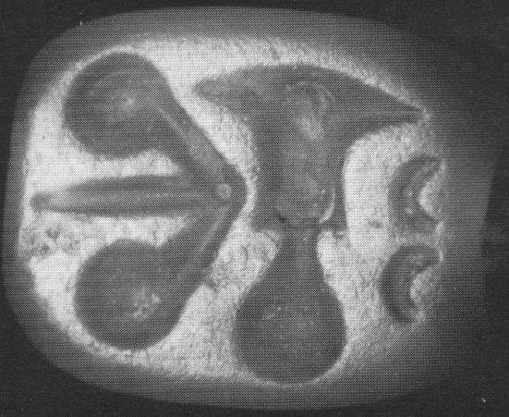

**[Element A](http://fenzi.dssg.unifi.it/dbas/seal.php?idseal=182" \t "_blank)**[: trowel (also CHIC 044) (tools) - main element  
standing left: arrow (also CHIC 049)  
standing right: lunette](http://fenzi.dssg.unifi.it/dbas/seal.php?idseal=182" \t "_blank)**[Element B](http://fenzi.dssg.unifi.it/dbas/seal.php?idseal=182" \t "_blank)**[: arrow (also CHIC 049) (tools) - main element  
standing right: trowel (also CHIC 044)  
- no relation: lunette](http://fenzi.dssg.unifi.it/dbas/seal.php?idseal=182" \t "_blank)**[Element C](http://fenzi.dssg.unifi.it/dbas/seal.php?idseal=182" \t "_blank)**[: lunette (geometric patterns) - secondary element  
standing left: trowel (also CHIC 044)  
- no relation: arrow (also CHIC 049)](http://fenzi.dssg.unifi.it/dbas/seal.php?idseal=182" \t "_blank)

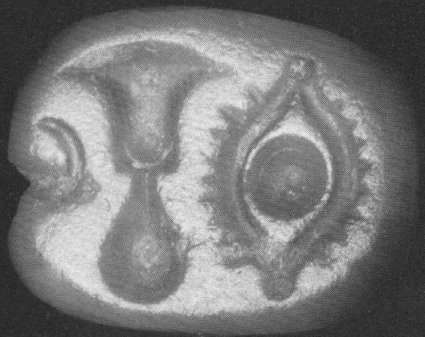

**[Element A](http://fenzi.dssg.unifi.it/dbas/seal.php?idseal=182" \t "_blank)**[: trowel (also CHIC 044) (tools) - main element  
standing right: eye (also CHIC 005)  
standing left: lunette](http://fenzi.dssg.unifi.it/dbas/seal.php?idseal=182" \t "_blank)**[Element B](http://fenzi.dssg.unifi.it/dbas/seal.php?idseal=182" \t "_blank)**[: eye (also CHIC 005) (human figures) - main element  
standing left: trowel (also CHIC 044)  
- no relation: lunette](http://fenzi.dssg.unifi.it/dbas/seal.php?idseal=182" \t "_blank)**[Element C](http://fenzi.dssg.unifi.it/dbas/seal.php?idseal=182" \t "_blank)**[: lunette (geometric patterns) - secondary element  
standing right: trowel (also CHIC 044)  
- no relation: eye (also CHIC 005)](http://fenzi.dssg.unifi.it/dbas/seal.php?idseal=182" \t "_blank)

|  |  |
| --- | --- |
|  | **[cms:](http://fenzi.dssg.unifi.it/dbas/seal.php?idseal=182" \t "_blank)** [Vol. 2 supp. 2 Nr. 315](http://fenzi.dssg.unifi.it/dbas/seal.php?idseal=182" \t "_blank) |
| **[chic:](http://fenzi.dssg.unifi.it/dbas/seal.php?idseal=182" \t "_blank)** [Nr. 291](http://fenzi.dssg.unifi.it/dbas/seal.php?idseal=182" \t "_blank) |
| **[place of finding:](http://fenzi.dssg.unifi.it/dbas/seal.php?idseal=182" \t "_blank)** [-unknown](http://fenzi.dssg.unifi.it/dbas/seal.php?idseal=182" \t "_blank) **[context:](http://fenzi.dssg.unifi.it/dbas/seal.php?idseal=182" \t "_blank)** [- unknown context](http://fenzi.dssg.unifi.it/dbas/seal.php?idseal=182" \t "_blank) |
| **[material:](http://fenzi.dssg.unifi.it/dbas/seal.php?idseal=182" \t "_blank)** [steatite](http://fenzi.dssg.unifi.it/dbas/seal.php?idseal=182" \t "_blank) **[shape:](http://fenzi.dssg.unifi.it/dbas/seal.php?idseal=182" \t "_blank)** [4-sided prism](http://fenzi.dssg.unifi.it/dbas/seal.php?idseal=182" \t "_blank) |

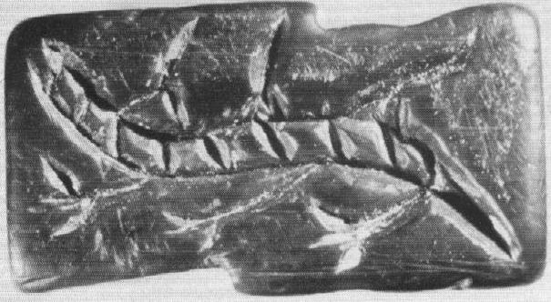

**[Element A](http://fenzi.dssg.unifi.it/dbas/seal.php?idseal=182" \t "_blank)**[: lizard (animals) - main element](http://fenzi.dssg.unifi.it/dbas/seal.php?idseal=182" \t "_blank)

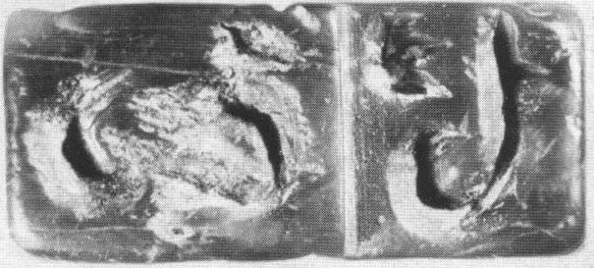

**[Element A](http://fenzi.dssg.unifi.it/dbas/seal.php?idseal=182" \t "_blank)**[: j-hook (also CHIC 059, 302) (geometric patterns) - main element  
- no relation: s-hook (spiral) (also CHIC 309)  
standing near left down: petaloid design  
standing left: bar](http://fenzi.dssg.unifi.it/dbas/seal.php?idseal=182" \t "_blank)**[Element B](http://fenzi.dssg.unifi.it/dbas/seal.php?idseal=182" \t "_blank)**[: s-hook (spiral) (also CHIC 309) (geometric patterns) - main element  
- no relation: j-hook (also CHIC 059, 302)  
- no relation: petaloid design  
standing right: bar](http://fenzi.dssg.unifi.it/dbas/seal.php?idseal=182" \t "_blank)**[Element C](http://fenzi.dssg.unifi.it/dbas/seal.php?idseal=182" \t "_blank)**[: petaloid design (flora) - secondary element  
standing near right up: j-hook (also CHIC 059, 302)  
- no relation: s-hook (spiral) (also CHIC 309)  
standing left: bar](http://fenzi.dssg.unifi.it/dbas/seal.php?idseal=182" \t "_blank)**[Element D](http://fenzi.dssg.unifi.it/dbas/seal.php?idseal=182" \t "_blank)**[: bar (geometric patterns) - main element  
standing right: j-hook (also CHIC 059, 302)  
standing left: s-hook (spiral) (also CHIC 309)  
standing right: petaloid design](http://fenzi.dssg.unifi.it/dbas/seal.php?idseal=182" \t "_blank)

**[group of signs](http://fenzi.dssg.unifi.it/dbas/seal.php?idseal=182" \t "_blank)**[:  
h e   
the B element is partially missing. we can see only the upper and the lower part of the S-hook, resembling two lunettes. the A and B elements are divided by a step,and a bar (element D)engraved on the seal.](http://fenzi.dssg.unifi.it/dbas/seal.php?idseal=182" \t "_blank)

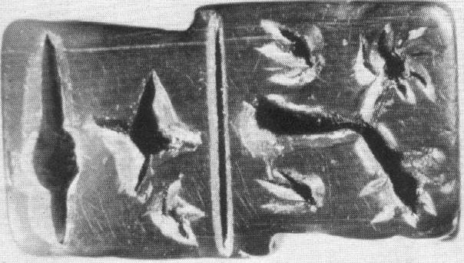

**[Element A](http://fenzi.dssg.unifi.it/dbas/seal.php?idseal=182" \t "_blank)**[: fig (also CHIC \*155) (flora) - main element  
standing above: bar  
- no relation: cross (also CHIC 307)  
- no relation: pin with a circle in the middle (also CHIC 063)  
standing right: petaloid design  
standing left: petaloid design  
- no relation: petaloid design](http://fenzi.dssg.unifi.it/dbas/seal.php?idseal=182" \t "_blank)**[Element B](http://fenzi.dssg.unifi.it/dbas/seal.php?idseal=182" \t "_blank)**[: bar (geometric patterns) - main element  
standing below: fig (also CHIC \*155)  
standing above: cross (also CHIC 307)  
- no relation: pin with a circle in the middle (also CHIC 063)  
standing below: petaloid design  
standing below: petaloid design  
standing above: petaloid design](http://fenzi.dssg.unifi.it/dbas/seal.php?idseal=182" \t "_blank)**[Element C](http://fenzi.dssg.unifi.it/dbas/seal.php?idseal=182" \t "_blank)**[: cross (also CHIC 307) (geometric patterns) - main element  
- no relation: fig (also CHIC \*155)  
standing below: bar  
standing above: pin with a circle in the middle (also CHIC 063)  
- no relation: petaloid design  
- no relation: petaloid design  
standing right: petaloid design](http://fenzi.dssg.unifi.it/dbas/seal.php?idseal=182" \t "_blank)**[Element D](http://fenzi.dssg.unifi.it/dbas/seal.php?idseal=182" \t "_blank)**[: pin with a circle in the middle (also CHIC 063) (geometric patterns) - main element  
- no relation: fig (also CHIC \*155)  
- no relation: bar  
standing below: cross (also CHIC 307)  
- no relation: petaloid design  
- no relation: petaloid design  
- no relation: petaloid design](http://fenzi.dssg.unifi.it/dbas/seal.php?idseal=182" \t "_blank)**[Element E](http://fenzi.dssg.unifi.it/dbas/seal.php?idseal=182" \t "_blank)**[: petaloid design (flora) - secondary element  
standing left: fig (also CHIC \*155)  
standing above: bar  
- no relation: cross (also CHIC 307)  
- no relation: pin with a circle in the middle (also CHIC 063)  
- no relation: petaloid design  
- no relation: petaloid design](http://fenzi.dssg.unifi.it/dbas/seal.php?idseal=182" \t "_blank)**[Element F](http://fenzi.dssg.unifi.it/dbas/seal.php?idseal=182" \t "_blank)**[: petaloid design (flora) - secondary element  
standing right: fig (also CHIC \*155)  
standing above: bar  
- no relation: cross (also CHIC 307)  
- no relation: pin with a circle in the middle (also CHIC 063)  
- no relation: petaloid design  
- no relation: petaloid design](http://fenzi.dssg.unifi.it/dbas/seal.php?idseal=182" \t "_blank)**[Element G](http://fenzi.dssg.unifi.it/dbas/seal.php?idseal=182" \t "_blank)**[: petaloid design (flora) - secondary element  
- no relation: fig (also CHIC \*155)  
standing below: bar  
standing left: cross (also CHIC 307)  
- no relation: pin with a circle in the middle (also CHIC 063)  
- no relation: petaloid design  
- no relation: petaloid design](http://fenzi.dssg.unifi.it/dbas/seal.php?idseal=182" \t "_blank)

[the D element could also be a dot with outgoing elements. the B element diveides A from C+D elements, and corresponds to the step on the Face B.](http://fenzi.dssg.unifi.it/dbas/seal.php?idseal=182" \t "_blank)

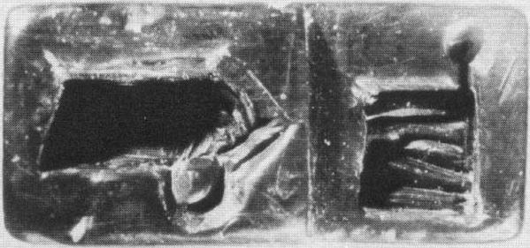

**[Element A](http://fenzi.dssg.unifi.it/dbas/seal.php?idseal=182" \t "_blank)**[: rectangle with vertical line (also CHIC 308) (geometric patterns) - main element  
- no relation: handled cilinder vessel with lid (also CHIC 157)  
standing above: bar](http://fenzi.dssg.unifi.it/dbas/seal.php?idseal=182" \t "_blank)**[Element B](http://fenzi.dssg.unifi.it/dbas/seal.php?idseal=182" \t "_blank)**[: handled cilinder vessel with lid (also CHIC 157) (vessels) - main element  
- no relation: rectangle with vertical line (also CHIC 308)  
standing below: bar](http://fenzi.dssg.unifi.it/dbas/seal.php?idseal=182" \t "_blank)**[Element C](http://fenzi.dssg.unifi.it/dbas/seal.php?idseal=182" \t "_blank)**[: bar (geometric patterns) - main element  
standing below: rectangle with vertical line (also CHIC 308)  
standing above: handled cilinder vessel with lid (also CHIC 157)](http://fenzi.dssg.unifi.it/dbas/seal.php?idseal=182" \t "_blank)

**[group of signs](http://fenzi.dssg.unifi.it/dbas/seal.php?idseal=182" \t "_blank)**[:  
b g   
A step (element C) divides the element A from the element B. The element A may correspond to the gate (CHIC 038).](http://fenzi.dssg.unifi.it/dbas/seal.php?idseal=182" \t "_blank)

|  |  |
| --- | --- |
|  | **[cms:](http://fenzi.dssg.unifi.it/dbas/seal.php?idseal=182" \t "_blank)** [Vol. 2 supp. 2 Nr. 316](http://fenzi.dssg.unifi.it/dbas/seal.php?idseal=182" \t "_blank) |
| **[chic:](http://fenzi.dssg.unifi.it/dbas/seal.php?idseal=182" \t "_blank)** [Nr. 295](http://fenzi.dssg.unifi.it/dbas/seal.php?idseal=182" \t "_blank) |
| **[place of finding:](http://fenzi.dssg.unifi.it/dbas/seal.php?idseal=182" \t "_blank)** [-unknown](http://fenzi.dssg.unifi.it/dbas/seal.php?idseal=182" \t "_blank) **[context:](http://fenzi.dssg.unifi.it/dbas/seal.php?idseal=182" \t "_blank)** [- unknown context](http://fenzi.dssg.unifi.it/dbas/seal.php?idseal=182" \t "_blank) |
| **[material:](http://fenzi.dssg.unifi.it/dbas/seal.php?idseal=182" \t "_blank)** [jasper](http://fenzi.dssg.unifi.it/dbas/seal.php?idseal=182" \t "_blank) **[shape:](http://fenzi.dssg.unifi.it/dbas/seal.php?idseal=182" \t "_blank)** [4-sided prism](http://fenzi.dssg.unifi.it/dbas/seal.php?idseal=182" \t "_blank) |

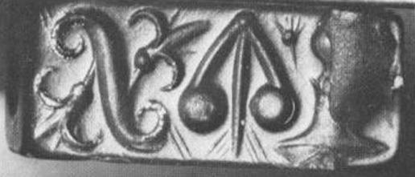

**[Element A](http://fenzi.dssg.unifi.it/dbas/seal.php?idseal=182" \t "_blank)**[: trowel (also CHIC 044) (tools) - main element  
standing left: arrow (also CHIC 049)  
- no relation: s-hook (spiral) (also CHIC 309)  
- no relation: flower (lily)  
- no relation: flower (lily)](http://fenzi.dssg.unifi.it/dbas/seal.php?idseal=182" \t "_blank)**[Element B](http://fenzi.dssg.unifi.it/dbas/seal.php?idseal=182" \t "_blank)**[: arrow (also CHIC 049) (tools) - main element ?????  
standing right: trowel (also CHIC 044)  
standing left: s-hook (spiral) (also CHIC 309)  
standing left: flower (lily)  
- no relation: flower (lily)](http://fenzi.dssg.unifi.it/dbas/seal.php?idseal=182" \t "_blank)

**[Element D [C]](http://fenzi.dssg.unifi.it/dbas/seal.php?idseal=182" \t "_blank)**[: flower (lily) (flora) - secondary element MISPLACED ELEMENY  
- no relation: trowel (also CHIC 044)  
standing right: arrow (also CHIC 049)  
standing left: s-hook (spiral) (also CHIC 309)  
- no relation: flower (lily)](http://fenzi.dssg.unifi.it/dbas/seal.php?idseal=182" \t "_blank)**[Element C](http://fenzi.dssg.unifi.it/dbas/seal.php?idseal=182" \t "_blank)**[: s-hook (spiral) (also CHIC 309) (geometric patterns) - main element  
- no relation: trowel (also CHIC 044)  
standing right: arrow (also CHIC 049)  
standing right: flower (lily)  
standing left: flower (lily)](http://fenzi.dssg.unifi.it/dbas/seal.php?idseal=182" \t "_blank) **[Element E](http://fenzi.dssg.unifi.it/dbas/seal.php?idseal=182" \t "_blank)**[: flower (lily) (flora) - secondary element  
- no relation: trowel (also CHIC 044)  
- no relation: arrow (also CHIC 049)  
standing right: s-hook (spiral) (also CHIC 309)  
- no relation: flower (lily)](http://fenzi.dssg.unifi.it/dbas/seal.php?idseal=182" \t "_blank)

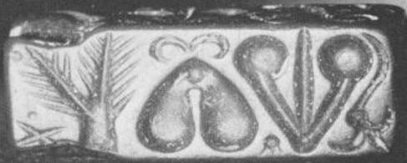

**[Element A [B]](http://fenzi.dssg.unifi.it/dbas/seal.php?idseal=182" \t "_blank)**[: olive spray (also CHIC 029) (flora) - main element BAOBAB TREE ???  
standing right: two jointed ovals (also CHIC 077)  
- no relation: arrow (also CHIC 049)  
standing left: X (also CHIC Stiktogram)  
standing right: lunette  
- no relation: flower (lily)](http://fenzi.dssg.unifi.it/dbas/seal.php?idseal=182" \t "_blank)**[Element B](http://fenzi.dssg.unifi.it/dbas/seal.php?idseal=182" \t "_blank)**[: two jointed ovals (also CHIC 077) (geometric patterns) - main element LUNGS ??? with two lunette curves above  
standing left: olive spray (also CHIC 029)  
standing right: arrow (also CHIC 049)  
- no relation: X (also CHIC Stiktogram)  
standing below: lunette  
- no relation: flower (lily)](http://fenzi.dssg.unifi.it/dbas/seal.php?idseal=182" \t "_blank)**[Element C](http://fenzi.dssg.unifi.it/dbas/seal.php?idseal=182" \t "_blank)**[: arrow (also CHIC 049) (tools) - main element TRACHEA ???  
- no relation: olive spray (also CHIC 029)  
standing left: two jointed ovals (also CHIC 077)  
- no relation: X (also CHIC Stiktogram)  
standing left: lunette  
standing right: flower (lily)](http://fenzi.dssg.unifi.it/dbas/seal.php?idseal=182" \t "_blank)**[Element D [A]](http://fenzi.dssg.unifi.it/dbas/seal.php?idseal=182" \t "_blank)**[: X (also CHIC Stiktogram) (geometric patterns) - secondary element  
standing right: olive spray (also CHIC 029)  
- no relation: two jointed ovals (also CHIC 077)  
- no relation: arrow (also CHIC 049)  
- no relation: lunette  
- no relation: flower (lily)](http://fenzi.dssg.unifi.it/dbas/seal.php?idseal=182" \t "_blank)**[Element E](http://fenzi.dssg.unifi.it/dbas/seal.php?idseal=182" \t "_blank)**[: 2 lunettes (geometric patterns) - secondary element   
standing left: olive spray (also CHIC 029)  
standing above: two jointed ovals (also CHIC 077)  
standing right: arrow (also CHIC 049)  
- no relation: X (also CHIC Stiktogram)  
- no relation: flower (lily)](http://fenzi.dssg.unifi.it/dbas/seal.php?idseal=182" \t "_blank)**[Element F](http://fenzi.dssg.unifi.it/dbas/seal.php?idseal=182" \t "_blank)**[: flower (lily) (flora) - secondary element  
- no relation: olive spray (also CHIC 029)  
- no relation: two jointed ovals (also CHIC 077)  
standing left: arrow (also CHIC 049)  
- no relation: X (also CHIC Stiktogram)  
- no relation: lunette](http://fenzi.dssg.unifi.it/dbas/seal.php?idseal=182" \t "_blank)

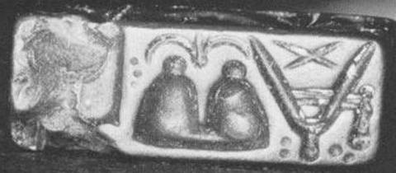

**[Element A](http://fenzi.dssg.unifi.it/dbas/seal.php?idseal=182" \t "_blank)**[: mallet (also CHIC 056) (tools) - main element  
standing right: mountains design (also CHIC 034)  
- no relation: sistrum (also CHIC 057)  
- no relation: X (also CHIC Stiktogram)  
standing right: lunette](http://fenzi.dssg.unifi.it/dbas/seal.php?idseal=182" \t "_blank)**[Element B](http://fenzi.dssg.unifi.it/dbas/seal.php?idseal=182" \t "_blank)**[: mountains design (also CHIC 034) (geometric patterns) - main element two lunette curves above  
standing left: mallet (also CHIC 056)  
standing right: sistrum (also CHIC 057)  
- no relation: X (also CHIC Stiktogram)  
standing below: lunette](http://fenzi.dssg.unifi.it/dbas/seal.php?idseal=182" \t "_blank)**[Element C](http://fenzi.dssg.unifi.it/dbas/seal.php?idseal=182" \t "_blank)**[: sistrum (also CHIC 057) (tools) - main element  
- no relation: mallet (also CHIC 056)  
standing left: mountains design (also CHIC 034)  
standing around: X (also CHIC Stiktogram)  
standing left: lunette](http://fenzi.dssg.unifi.it/dbas/seal.php?idseal=182" \t "_blank)**[Element D](http://fenzi.dssg.unifi.it/dbas/seal.php?idseal=182" \t "_blank)**[: X (also CHIC Stiktogram) (geometric patterns) - secondary element  
- no relation: mallet (also CHIC 056)  
- no relation: mountains design (also CHIC 034)  
standing inside: sistrum (also CHIC 057)  
- no relation: lunette](http://fenzi.dssg.unifi.it/dbas/seal.php?idseal=182" \t "_blank)**[Element E](http://fenzi.dssg.unifi.it/dbas/seal.php?idseal=182" \t "_blank)**[: lunette (geometric patterns) - secondary element  
standing left: mallet (also CHIC 056)  
standing above: mountains design (also CHIC 034)  
standing right: sistrum (also CHIC 057)  
- no relation: X (also CHIC Stiktogram)](http://fenzi.dssg.unifi.it/dbas/seal.php?idseal=182" \t "_blank)

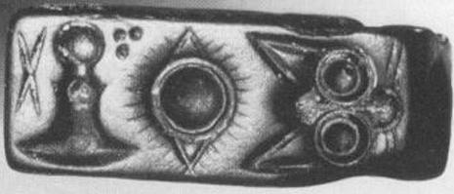

**[Element A](http://fenzi.dssg.unifi.it/dbas/seal.php?idseal=182" \t "_blank)**[: trowel (also CHIC 044) (tools) - main element  
standing right: eye (also CHIC 005)  
- no relation: cat mask  
standing left: X (also CHIC Stiktogram)](http://fenzi.dssg.unifi.it/dbas/seal.php?idseal=182" \t "_blank)**[Element B](http://fenzi.dssg.unifi.it/dbas/seal.php?idseal=182" \t "_blank)**[: eye (also CHIC 005) (human figures) - main element  
standing left: trowel (also CHIC 044)  
standing right: cat mask  
- no relation: X (also CHIC Stiktogram)](http://fenzi.dssg.unifi.it/dbas/seal.php?idseal=182" \t "_blank)**[Element C](http://fenzi.dssg.unifi.it/dbas/seal.php?idseal=182" \t "_blank)**[: cat mask (animals) - main element  
- no relation: trowel (also CHIC 044)  
standing left: eye (also CHIC 005)  
- no relation: X (also CHIC Stiktogram)](http://fenzi.dssg.unifi.it/dbas/seal.php?idseal=182" \t "_blank)**[Element D](http://fenzi.dssg.unifi.it/dbas/seal.php?idseal=182" \t "_blank)**[: X (also CHIC Stiktogram) (geometric patterns) - secondary element  
standing right: trowel (also CHIC 044)  
- no relation: eye (also CHIC 005)  
- no relation: cat mask](http://fenzi.dssg.unifi.it/dbas/seal.php?idseal=182" \t "_blank)

|  |  |
| --- | --- |
|  | **[cms:](http://fenzi.dssg.unifi.it/dbas/seal.php?idseal=182" \t "_blank)** [Vol. 3 supp. 0 Nr. 0](http://fenzi.dssg.unifi.it/dbas/seal.php?idseal=182" \t "_blank) |
| **[chic:](http://fenzi.dssg.unifi.it/dbas/seal.php?idseal=182" \t "_blank)** [Nr. 206](http://fenzi.dssg.unifi.it/dbas/seal.php?idseal=182" \t "_blank) |
| **[place of finding:](http://fenzi.dssg.unifi.it/dbas/seal.php?idseal=182" \t "_blank)** [-unknown](http://fenzi.dssg.unifi.it/dbas/seal.php?idseal=182" \t "_blank) **[context:](http://fenzi.dssg.unifi.it/dbas/seal.php?idseal=182" \t "_blank)** [- unknown context](http://fenzi.dssg.unifi.it/dbas/seal.php?idseal=182" \t "_blank) |
| **[material:](http://fenzi.dssg.unifi.it/dbas/seal.php?idseal=182" \t "_blank)** [onyx](http://fenzi.dssg.unifi.it/dbas/seal.php?idseal=182" \t "_blank) **[shape:](http://fenzi.dssg.unifi.it/dbas/seal.php?idseal=182" \t "_blank)** [flat cylinder](http://fenzi.dssg.unifi.it/dbas/seal.php?idseal=182" \t "_blank)  **[material](http://fenzi.dssg.unifi.it/dbas/seal.php?idseal=182" \t "_blank)**[: onyx (hard stones)](http://fenzi.dssg.unifi.it/dbas/seal.php?idseal=182" \t "_blank) **[dimensions mm](http://fenzi.dssg.unifi.it/dbas/seal.php?idseal=182" \t "_blank)**[: max 18.00 min 13.00 base 0.00 height 7.00](http://fenzi.dssg.unifi.it/dbas/seal.php?idseal=182" \t "_blank) **[bibliography](http://fenzi.dssg.unifi.it/dbas/seal.php?idseal=182" \t "_blank)**[:](http://fenzi.dssg.unifi.it/dbas/seal.php?idseal=182" \t "_blank) **[place of conservation](http://fenzi.dssg.unifi.it/dbas/seal.php?idseal=182" \t "_blank)**[: Iraklion Museum](http://fenzi.dssg.unifi.it/dbas/seal.php?idseal=182" \t "_blank) |

[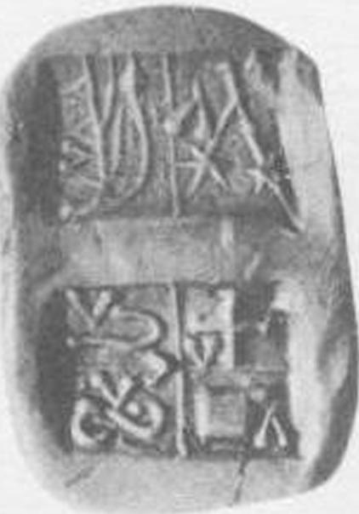](http://fenzi.dssg.unifi.it/dbas/seal.php?idseal=182" \t "_blank)

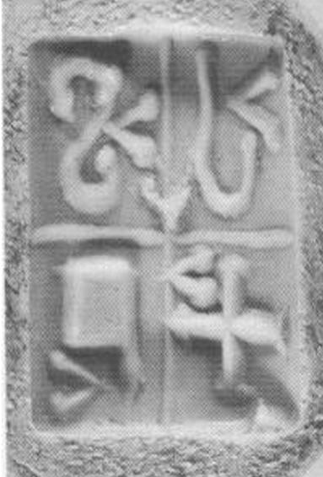

[with each element is - secondary angle element TRACHEA ???](http://fenzi.dssg.unifi.it/dbas/seal.php?idseal=182" \t "_blank)

**[Element A](http://fenzi.dssg.unifi.it/dbas/seal.php?idseal=182" \t "_blank)**[: s-hook (spiral) (also CHIC 309) (geometric patterns) - main element](http://fenzi.dssg.unifi.it/dbas/seal.php?idseal=182" \t "_blank)

**[Element C](http://fenzi.dssg.unifi.it/dbas/seal.php?idseal=182" \t "_blank)**[: j-hook](http://fenzi.dssg.unifi.it/dbas/seal.php?idseal=182" \t "_blank)

**[Element F](http://fenzi.dssg.unifi.it/dbas/seal.php?idseal=182" \t "_blank)**[: rectangle with vertical line (also CHIC 308) (geometric patterns) - main element](http://fenzi.dssg.unifi.it/dbas/seal.php?idseal=182" \t "_blank)

**[Element H](http://fenzi.dssg.unifi.it/dbas/seal.php?idseal=182" \t "_blank)**[: cross pommée (also CHIC 070) (geometric patterns) - main element](http://fenzi.dssg.unifi.it/dbas/seal.php?idseal=182" \t "_blank)

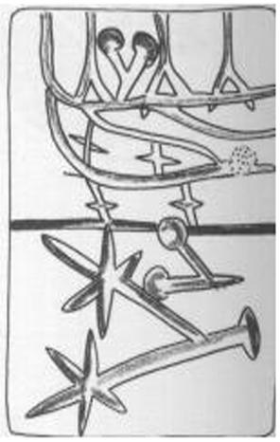

**[Element A](http://fenzi.dssg.unifi.it/dbas/seal.php?idseal=182" \t "_blank)**[: vine (also CHIC \*156) (flora) - main element  
standing below: angle element  
- no relation: fig (also CHIC \*155)  
- no relation: angle element](http://fenzi.dssg.unifi.it/dbas/seal.php?idseal=182" \t "_blank)**[Element B](http://fenzi.dssg.unifi.it/dbas/seal.php?idseal=182" \t "_blank)**[: angle element (geometric patterns) - secondary element  
standing above: vine (also CHIC \*156)  
- no relation: fig (also CHIC \*155)  
- no relation: angle element](http://fenzi.dssg.unifi.it/dbas/seal.php?idseal=182" \t "_blank)**[Element C](http://fenzi.dssg.unifi.it/dbas/seal.php?idseal=182" \t "_blank)**[: fig (also CHIC \*155) (flora) - main element  
- no relation: vine (also CHIC \*156)  
- no relation: angle element  
standing below: angle element](http://fenzi.dssg.unifi.it/dbas/seal.php?idseal=182" \t "_blank)**[Element D](http://fenzi.dssg.unifi.it/dbas/seal.php?idseal=182" \t "_blank)**[: angle element (geometric patterns) - secondary element  
- no relation: vine (also CHIC \*156)  
- no relation: angle element  
standing above: fig (also CHIC \*155)](http://fenzi.dssg.unifi.it/dbas/seal.php?idseal=182" \t "_blank)

**[group of signs](http://fenzi.dssg.unifi.it/dbas/seal.php?idseal=182" \t "_blank)**[:  
` a   
Face B is divided into two fields by an horizontal line, so each main element is related to the secondary element in its field, but not with the other signs.](http://fenzi.dssg.unifi.it/dbas/seal.php?idseal=182" \t "_blank)

|  |  |
| --- | --- |
|  | **[cms:](http://fenzi.dssg.unifi.it/dbas/seal.php?idseal=182" \t "_blank)** [Vol. 3 supp. 0 Nr. 0](http://fenzi.dssg.unifi.it/dbas/seal.php?idseal=182" \t "_blank) |
| **[chic:](http://fenzi.dssg.unifi.it/dbas/seal.php?idseal=182" \t "_blank)** [Nr. 180](http://fenzi.dssg.unifi.it/dbas/seal.php?idseal=182" \t "_blank) |
| **[place of finding:](http://fenzi.dssg.unifi.it/dbas/seal.php?idseal=182" \t "_blank)** [-unknown](http://fenzi.dssg.unifi.it/dbas/seal.php?idseal=182" \t "_blank) **[context:](http://fenzi.dssg.unifi.it/dbas/seal.php?idseal=182" \t "_blank)** [- unknown context](http://fenzi.dssg.unifi.it/dbas/seal.php?idseal=182" \t "_blank) |
| **[material:](http://fenzi.dssg.unifi.it/dbas/seal.php?idseal=182" \t "_blank)** [steatite](http://fenzi.dssg.unifi.it/dbas/seal.php?idseal=182" \t "_blank) **[shape:](http://fenzi.dssg.unifi.it/dbas/seal.php?idseal=182" \t "_blank)** [signet](http://fenzi.dssg.unifi.it/dbas/seal.php?idseal=182" \t "_blank) |

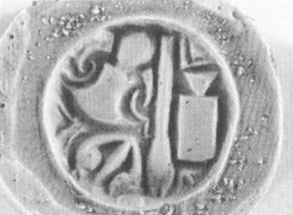

**[Element A](http://fenzi.dssg.unifi.it/dbas/seal.php?idseal=182" \t "_blank)**[: trowel (also CHIC 044) (tools) - main element  
standing below: arrow (also CHIC 049)  
standing right: spear (also CHIC 050)  
- no relation: mallet (also CHIC 056)](http://fenzi.dssg.unifi.it/dbas/seal.php?idseal=182" \t "_blank)**[Element B](http://fenzi.dssg.unifi.it/dbas/seal.php?idseal=182" \t "_blank)**[: arrow (also CHIC 049) (tools) - main element  
standing above: trowel (also CHIC 044)  
standing right: spear (also CHIC 050)  
- no relation: mallet (also CHIC 056)](http://fenzi.dssg.unifi.it/dbas/seal.php?idseal=182" \t "_blank)**[Element C](http://fenzi.dssg.unifi.it/dbas/seal.php?idseal=182" \t "_blank)**[: spear (also CHIC 050) (tools) - main element  
standing left: trowel (also CHIC 044)  
standing left: arrow (also CHIC 049)  
standing right: mallet (also CHIC 056)](http://fenzi.dssg.unifi.it/dbas/seal.php?idseal=182" \t "_blank)**[Element D](http://fenzi.dssg.unifi.it/dbas/seal.php?idseal=182" \t "_blank)**[: mallet (also CHIC 056) (tools) - main element  
- no relation: trowel (also CHIC 044)  
- no relation: arrow (also CHIC 049)  
standing left: spear (also CHIC 050)](http://fenzi.dssg.unifi.it/dbas/seal.php?idseal=182" \t "_blank)

|  |  |
| --- | --- |
|  | **[cms:](http://fenzi.dssg.unifi.it/dbas/seal.php?idseal=182" \t "_blank)** [Vol. 3 supp. 0 Nr. 0](http://fenzi.dssg.unifi.it/dbas/seal.php?idseal=182" \t "_blank) |
| **[chic:](http://fenzi.dssg.unifi.it/dbas/seal.php?idseal=182" \t "_blank)** [Nr. 211](http://fenzi.dssg.unifi.it/dbas/seal.php?idseal=182" \t "_blank) |
| **[place of finding:](http://fenzi.dssg.unifi.it/dbas/seal.php?idseal=182" \t "_blank)** [-unknown](http://fenzi.dssg.unifi.it/dbas/seal.php?idseal=182" \t "_blank) **[context:](http://fenzi.dssg.unifi.it/dbas/seal.php?idseal=182" \t "_blank)** [- unknown context](http://fenzi.dssg.unifi.it/dbas/seal.php?idseal=182" \t "_blank) |
| **[material:](http://fenzi.dssg.unifi.it/dbas/seal.php?idseal=182" \t "_blank)** [steatite](http://fenzi.dssg.unifi.it/dbas/seal.php?idseal=182" \t "_blank) **[shape:](http://fenzi.dssg.unifi.it/dbas/seal.php?idseal=182" \t "_blank)** [3-sided prism](http://fenzi.dssg.unifi.it/dbas/seal.php?idseal=182" \t "_blank) |

[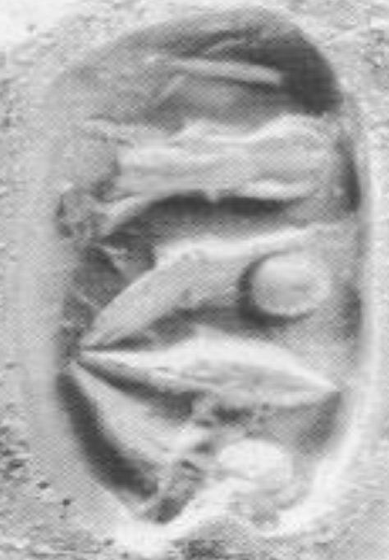](http://fenzi.dssg.unifi.it/dbas/seal.php?idseal=182" \t "_blank)**[Element A](http://fenzi.dssg.unifi.it/dbas/seal.php?idseal=182" \t "_blank)**[: X (also CHIC Stiktogram) (geometric patterns) - secondary element  
standing left: trowel (also CHIC 044)  
- no relation: arrow (also CHIC 049)](http://fenzi.dssg.unifi.it/dbas/seal.php?idseal=182" \t "_blank)**[Element B](http://fenzi.dssg.unifi.it/dbas/seal.php?idseal=182" \t "_blank)**[: trowel (also CHIC 044) (tools) - main element  
standing right: X (also CHIC Stiktogram)  
standing left: arrow (also CHIC 049)](http://fenzi.dssg.unifi.it/dbas/seal.php?idseal=182" \t "_blank)**[Element C](http://fenzi.dssg.unifi.it/dbas/seal.php?idseal=182" \t "_blank)**[: arrow (also CHIC 049) (tools) - main element  
- no relation: X (also CHIC Stiktogram)  
standing right: trowel (also CHIC 044)](http://fenzi.dssg.unifi.it/dbas/seal.php?idseal=182" \t "_blank)

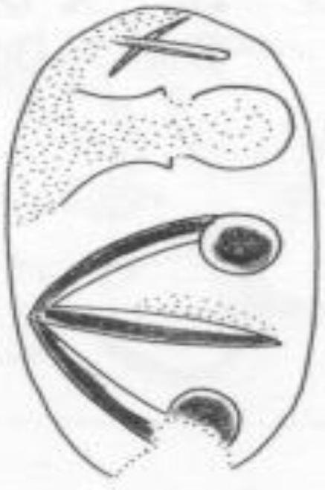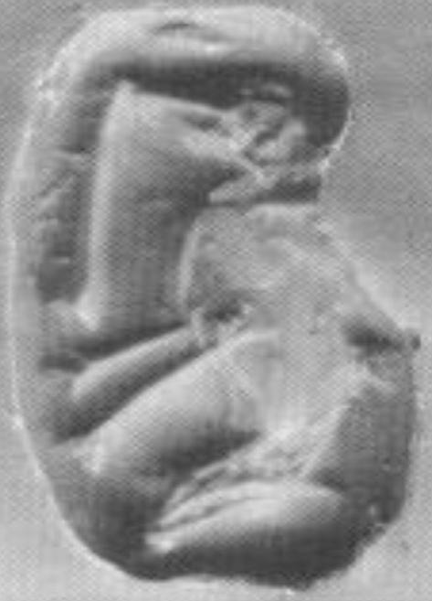

**[Element A](http://fenzi.dssg.unifi.it/dbas/seal.php?idseal=182" \t "_blank)**[: boar (animals) - main element](http://fenzi.dssg.unifi.it/dbas/seal.php?idseal=182" \t "_blank)

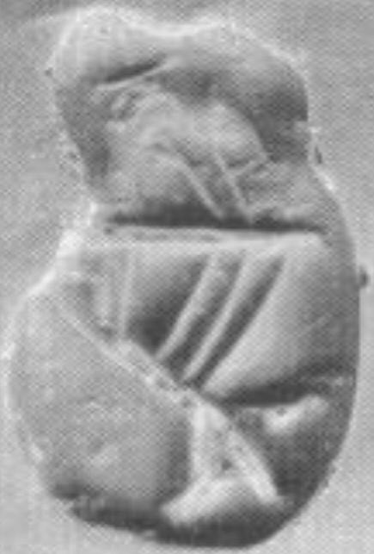

**[Element A](http://fenzi.dssg.unifi.it/dbas/seal.php?idseal=182" \t "_blank)**[: boat (ship) (also CHIC 040) (artefacts) - main element](http://fenzi.dssg.unifi.it/dbas/seal.php?idseal=182" \t "_blank)

|  |  |
| --- | --- |
|  | **[cms:](http://fenzi.dssg.unifi.it/dbas/seal.php?idseal=182" \t "_blank)** [Vol. 3 supp. 0 Nr. 0](http://fenzi.dssg.unifi.it/dbas/seal.php?idseal=182" \t "_blank) |
| **[chic:](http://fenzi.dssg.unifi.it/dbas/seal.php?idseal=182" \t "_blank)** [Nr. 210](http://fenzi.dssg.unifi.it/dbas/seal.php?idseal=182" \t "_blank) |
| **[place of finding:](http://fenzi.dssg.unifi.it/dbas/seal.php?idseal=182" \t "_blank)** [-unknown](http://fenzi.dssg.unifi.it/dbas/seal.php?idseal=182" \t "_blank) **[context:](http://fenzi.dssg.unifi.it/dbas/seal.php?idseal=182" \t "_blank)** [- unknown context](http://fenzi.dssg.unifi.it/dbas/seal.php?idseal=182" \t "_blank) |
| **[material:](http://fenzi.dssg.unifi.it/dbas/seal.php?idseal=182" \t "_blank)** [steatite](http://fenzi.dssg.unifi.it/dbas/seal.php?idseal=182" \t "_blank) **[shape:](http://fenzi.dssg.unifi.it/dbas/seal.php?idseal=182" \t "_blank)** [3-sided prism](http://fenzi.dssg.unifi.it/dbas/seal.php?idseal=182" \t "_blank) |

**[Element A](http://fenzi.dssg.unifi.it/dbas/seal.php?idseal=182" \t "_blank)**[: trowel (also CHIC 044) (tools) - main element  
standing above: arrow (also CHIC 049)](http://fenzi.dssg.unifi.it/dbas/seal.php?idseal=182" \t "_blank)**[Element B](http://fenzi.dssg.unifi.it/dbas/seal.php?idseal=182" \t "_blank)**[: arrow (also CHIC 049) (tools) - main element  
standing below: trowel (also CHIC 044)](http://fenzi.dssg.unifi.it/dbas/seal.php?idseal=182" \t "_blank)

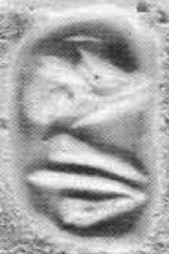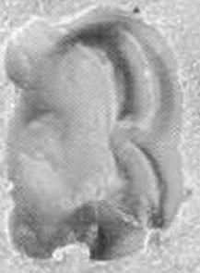

**[Element A](http://fenzi.dssg.unifi.it/dbas/seal.php?idseal=182" \t "_blank)**[: - not clear (unidentifiable) - main element](http://fenzi.dssg.unifi.it/dbas/seal.php?idseal=182" \t "_blank)

**[group of signs](http://fenzi.dssg.unifi.it/dbas/seal.php?idseal=182" \t "_blank)**[:  
  
the element A could be an insect (?) DOUBLE LUNETTE](http://fenzi.dssg.unifi.it/dbas/seal.php?idseal=182" \t "_blank)

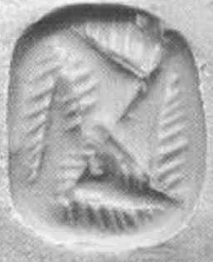

**[Element A](http://fenzi.dssg.unifi.it/dbas/seal.php?idseal=182" \t "_blank)**[: hooked cross (swastika) (geometric patterns) - main element](http://fenzi.dssg.unifi.it/dbas/seal.php?idseal=182" \t "_blank)

|  |  |
| --- | --- |
|  | **[cms:](http://fenzi.dssg.unifi.it/dbas/seal.php?idseal=182" \t "_blank)** [Vol. 3 supp. 0 Nr. 0](http://fenzi.dssg.unifi.it/dbas/seal.php?idseal=182" \t "_blank) |
| **[chic:](http://fenzi.dssg.unifi.it/dbas/seal.php?idseal=182" \t "_blank)** [Nr. 209](http://fenzi.dssg.unifi.it/dbas/seal.php?idseal=182" \t "_blank) |
| **[place of finding:](http://fenzi.dssg.unifi.it/dbas/seal.php?idseal=182" \t "_blank)** [-unknown](http://fenzi.dssg.unifi.it/dbas/seal.php?idseal=182" \t "_blank) **[context:](http://fenzi.dssg.unifi.it/dbas/seal.php?idseal=182" \t "_blank)** [- unknown context](http://fenzi.dssg.unifi.it/dbas/seal.php?idseal=182" \t "_blank) |
| **[material:](http://fenzi.dssg.unifi.it/dbas/seal.php?idseal=182" \t "_blank)** [steatite](http://fenzi.dssg.unifi.it/dbas/seal.php?idseal=182" \t "_blank) **[shape:](http://fenzi.dssg.unifi.it/dbas/seal.php?idseal=182" \t "_blank)** [3-sided prism](http://fenzi.dssg.unifi.it/dbas/seal.php?idseal=182" \t "_blank) |

|  |  |
| --- | --- |
|  | **[cms:](http://fenzi.dssg.unifi.it/dbas/seal.php?idseal=152" \t "_blank)** [Vol. 3 supp. 0 Nr. 0](http://fenzi.dssg.unifi.it/dbas/seal.php?idseal=152" \t "_blank) |
| **[chic:](http://fenzi.dssg.unifi.it/dbas/seal.php?idseal=152" \t "_blank)** [Nr. 242](http://fenzi.dssg.unifi.it/dbas/seal.php?idseal=152" \t "_blank) |
| **[place of finding:](http://fenzi.dssg.unifi.it/dbas/seal.php?idseal=152" \t "_blank)** [-unknown](http://fenzi.dssg.unifi.it/dbas/seal.php?idseal=152" \t "_blank) **[context:](http://fenzi.dssg.unifi.it/dbas/seal.php?idseal=152" \t "_blank)** [- unknown context](http://fenzi.dssg.unifi.it/dbas/seal.php?idseal=152" \t "_blank) |
| **[material:](http://fenzi.dssg.unifi.it/dbas/seal.php?idseal=152" \t "_blank)** [rock crystal](http://fenzi.dssg.unifi.it/dbas/seal.php?idseal=152" \t "_blank) **[shape:](http://fenzi.dssg.unifi.it/dbas/seal.php?idseal=152" \t "_blank)** [3-sided prism](http://fenzi.dssg.unifi.it/dbas/seal.php?idseal=152" \t "_blank) |

|  |  |
| --- | --- |
|  | **[cms:](http://fenzi.dssg.unifi.it/dbas/seal.php?idseal=46" \t "_blank)** [Vol. 4 supp. 0 Nr. 137](http://fenzi.dssg.unifi.it/dbas/seal.php?idseal=46" \t "_blank) |
| **[chic:](http://fenzi.dssg.unifi.it/dbas/seal.php?idseal=46" \t "_blank)** [Nr. 254](http://fenzi.dssg.unifi.it/dbas/seal.php?idseal=46" \t "_blank) |
| **[place of finding:](http://fenzi.dssg.unifi.it/dbas/seal.php?idseal=46" \t "_blank)** [-unknown](http://fenzi.dssg.unifi.it/dbas/seal.php?idseal=46" \t "_blank) **[context:](http://fenzi.dssg.unifi.it/dbas/seal.php?idseal=46" \t "_blank)** [- unknown context](http://fenzi.dssg.unifi.it/dbas/seal.php?idseal=46" \t "_blank) |
| **[material:](http://fenzi.dssg.unifi.it/dbas/seal.php?idseal=46" \t "_blank)** [jasper](http://fenzi.dssg.unifi.it/dbas/seal.php?idseal=46" \t "_blank) **[shape:](http://fenzi.dssg.unifi.it/dbas/seal.php?idseal=46" \t "_blank)** [3-sided prism](http://fenzi.dssg.unifi.it/dbas/seal.php?idseal=46" \t "_blank) |

|  |  |
| --- | --- |
|  | **[cms:](http://fenzi.dssg.unifi.it/dbas/seal.php?idseal=46" \t "_blank)** [Vol. 6 supp. 0 Nr. 0](http://fenzi.dssg.unifi.it/dbas/seal.php?idseal=46" \t "_blank) |
| **[chic:](http://fenzi.dssg.unifi.it/dbas/seal.php?idseal=46" \t "_blank)** [Nr. 194](http://fenzi.dssg.unifi.it/dbas/seal.php?idseal=46" \t "_blank) |
| **[place of finding:](http://fenzi.dssg.unifi.it/dbas/seal.php?idseal=46" \t "_blank)** [-unknown](http://fenzi.dssg.unifi.it/dbas/seal.php?idseal=46" \t "_blank) **[context:](http://fenzi.dssg.unifi.it/dbas/seal.php?idseal=46" \t "_blank)** [- unknown context](http://fenzi.dssg.unifi.it/dbas/seal.php?idseal=46" \t "_blank) |
| **[material:](http://fenzi.dssg.unifi.it/dbas/seal.php?idseal=46" \t "_blank)** [chalcedony](http://fenzi.dssg.unifi.it/dbas/seal.php?idseal=46" \t "_blank) **[shape:](http://fenzi.dssg.unifi.it/dbas/seal.php?idseal=46" \t "_blank)** [elliptical bead](http://fenzi.dssg.unifi.it/dbas/seal.php?idseal=46" \t "_blank) |

|  |  |
| --- | --- |
|  | **[cms:](http://fenzi.dssg.unifi.it/dbas/seal.php?idseal=46" \t "_blank)** [Vol. 6 supp. 0 Nr. 0](http://fenzi.dssg.unifi.it/dbas/seal.php?idseal=46" \t "_blank) |
| **[chic:](http://fenzi.dssg.unifi.it/dbas/seal.php?idseal=46" \t "_blank)** [Nr. 213](http://fenzi.dssg.unifi.it/dbas/seal.php?idseal=46" \t "_blank) |
| **[place of finding:](http://fenzi.dssg.unifi.it/dbas/seal.php?idseal=46" \t "_blank)** [-unknown](http://fenzi.dssg.unifi.it/dbas/seal.php?idseal=46" \t "_blank) **[context:](http://fenzi.dssg.unifi.it/dbas/seal.php?idseal=46" \t "_blank)** [- unknown context](http://fenzi.dssg.unifi.it/dbas/seal.php?idseal=46" \t "_blank) |
| **[material:](http://fenzi.dssg.unifi.it/dbas/seal.php?idseal=46" \t "_blank)** [steatite](http://fenzi.dssg.unifi.it/dbas/seal.php?idseal=46" \t "_blank) **[shape:](http://fenzi.dssg.unifi.it/dbas/seal.php?idseal=46" \t "_blank)** [3-sided prism](http://fenzi.dssg.unifi.it/dbas/seal.php?idseal=46" \t "_blank) |

|  |  |
| --- | --- |
|  | **[cms:](http://fenzi.dssg.unifi.it/dbas/seal.php?idseal=139" \t "_blank)** [Vol. 6 supp. 0 Nr. 0](http://fenzi.dssg.unifi.it/dbas/seal.php?idseal=139" \t "_blank) |
| **[chic:](http://fenzi.dssg.unifi.it/dbas/seal.php?idseal=139" \t "_blank)** [Nr. 215](http://fenzi.dssg.unifi.it/dbas/seal.php?idseal=139" \t "_blank) |
| **[place of finding:](http://fenzi.dssg.unifi.it/dbas/seal.php?idseal=139" \t "_blank)** [-unknown](http://fenzi.dssg.unifi.it/dbas/seal.php?idseal=139" \t "_blank) **[context:](http://fenzi.dssg.unifi.it/dbas/seal.php?idseal=139" \t "_blank)** [- unknown context](http://fenzi.dssg.unifi.it/dbas/seal.php?idseal=139" \t "_blank) |
| **[material:](http://fenzi.dssg.unifi.it/dbas/seal.php?idseal=139" \t "_blank)** [steatite](http://fenzi.dssg.unifi.it/dbas/seal.php?idseal=139" \t "_blank) **[shape:](http://fenzi.dssg.unifi.it/dbas/seal.php?idseal=139" \t "_blank)** [3-sided prism](http://fenzi.dssg.unifi.it/dbas/seal.php?idseal=139" \t "_blank) |

|  |  |
| --- | --- |
|  | **[cms:](http://fenzi.dssg.unifi.it/dbas/seal.php?idseal=139" \t "_blank)** [Vol. 6 supp. 0 Nr. 0](http://fenzi.dssg.unifi.it/dbas/seal.php?idseal=139" \t "_blank) |
| **[chic:](http://fenzi.dssg.unifi.it/dbas/seal.php?idseal=139" \t "_blank)** [Nr. 212](http://fenzi.dssg.unifi.it/dbas/seal.php?idseal=139" \t "_blank) |
| **[place of finding:](http://fenzi.dssg.unifi.it/dbas/seal.php?idseal=139" \t "_blank)** [-unknown](http://fenzi.dssg.unifi.it/dbas/seal.php?idseal=139" \t "_blank) **[context:](http://fenzi.dssg.unifi.it/dbas/seal.php?idseal=139" \t "_blank)** [- unknown context](http://fenzi.dssg.unifi.it/dbas/seal.php?idseal=139" \t "_blank) |
| **[material:](http://fenzi.dssg.unifi.it/dbas/seal.php?idseal=139" \t "_blank)** [steatite](http://fenzi.dssg.unifi.it/dbas/seal.php?idseal=139" \t "_blank) **[shape:](http://fenzi.dssg.unifi.it/dbas/seal.php?idseal=139" \t "_blank)** [3-sided prism](http://fenzi.dssg.unifi.it/dbas/seal.php?idseal=139" \t "_blank) |

|  |  |
| --- | --- |
|  | **[cms:](http://fenzi.dssg.unifi.it/dbas/seal.php?idseal=139" \t "_blank)** [Vol. 6 supp. 0 Nr. 0](http://fenzi.dssg.unifi.it/dbas/seal.php?idseal=139" \t "_blank) |
| **[chic:](http://fenzi.dssg.unifi.it/dbas/seal.php?idseal=139" \t "_blank)** [Nr. 255](http://fenzi.dssg.unifi.it/dbas/seal.php?idseal=139" \t "_blank) |
| **[place of finding:](http://fenzi.dssg.unifi.it/dbas/seal.php?idseal=139" \t "_blank)** [-unknown](http://fenzi.dssg.unifi.it/dbas/seal.php?idseal=139" \t "_blank) **[context:](http://fenzi.dssg.unifi.it/dbas/seal.php?idseal=139" \t "_blank)** [- unknown context](http://fenzi.dssg.unifi.it/dbas/seal.php?idseal=139" \t "_blank) |
| **[material:](http://fenzi.dssg.unifi.it/dbas/seal.php?idseal=139" \t "_blank)** [cornelian](http://fenzi.dssg.unifi.it/dbas/seal.php?idseal=139" \t "_blank) **[shape:](http://fenzi.dssg.unifi.it/dbas/seal.php?idseal=139" \t "_blank)** [3-sided prism](http://fenzi.dssg.unifi.it/dbas/seal.php?idseal=139" \t "_blank) |

|  |  |
| --- | --- |
|  | **[cms:](http://fenzi.dssg.unifi.it/dbas/seal.php?idseal=139" \t "_blank)** [Vol. 6 supp. 0 Nr. 0](http://fenzi.dssg.unifi.it/dbas/seal.php?idseal=139" \t "_blank) |
| **[chic:](http://fenzi.dssg.unifi.it/dbas/seal.php?idseal=139" \t "_blank)** [Nr. 257](http://fenzi.dssg.unifi.it/dbas/seal.php?idseal=139" \t "_blank) |
| **[place of finding:](http://fenzi.dssg.unifi.it/dbas/seal.php?idseal=139" \t "_blank)** [-unknown](http://fenzi.dssg.unifi.it/dbas/seal.php?idseal=139" \t "_blank) **[context:](http://fenzi.dssg.unifi.it/dbas/seal.php?idseal=139" \t "_blank)** [- unknown context](http://fenzi.dssg.unifi.it/dbas/seal.php?idseal=139" \t "_blank) |
| **[material:](http://fenzi.dssg.unifi.it/dbas/seal.php?idseal=139" \t "_blank)** [cornelian](http://fenzi.dssg.unifi.it/dbas/seal.php?idseal=139" \t "_blank) **[shape:](http://fenzi.dssg.unifi.it/dbas/seal.php?idseal=139" \t "_blank)** [3-sided prism](http://fenzi.dssg.unifi.it/dbas/seal.php?idseal=139" \t "_blank) |

|  |  |
| --- | --- |
|  | **[cms:](http://fenzi.dssg.unifi.it/dbas/seal.php?idseal=139" \t "_blank)** [Vol. 6 supp. 0 Nr. 0](http://fenzi.dssg.unifi.it/dbas/seal.php?idseal=139" \t "_blank) |
| **[chic:](http://fenzi.dssg.unifi.it/dbas/seal.php?idseal=139" \t "_blank)** [Nr. 256](http://fenzi.dssg.unifi.it/dbas/seal.php?idseal=139" \t "_blank) |
| **[place of finding:](http://fenzi.dssg.unifi.it/dbas/seal.php?idseal=139" \t "_blank)** [-unknown](http://fenzi.dssg.unifi.it/dbas/seal.php?idseal=139" \t "_blank) **[context:](http://fenzi.dssg.unifi.it/dbas/seal.php?idseal=139" \t "_blank)** [- unknown context](http://fenzi.dssg.unifi.it/dbas/seal.php?idseal=139" \t "_blank) |
| **[material:](http://fenzi.dssg.unifi.it/dbas/seal.php?idseal=139" \t "_blank)** [cornelian](http://fenzi.dssg.unifi.it/dbas/seal.php?idseal=139" \t "_blank) **[shape:](http://fenzi.dssg.unifi.it/dbas/seal.php?idseal=139" \t "_blank)** [3-sided prism](http://fenzi.dssg.unifi.it/dbas/seal.php?idseal=139" \t "_blank) |

|  |  |
| --- | --- |
|  | **[cms:](http://fenzi.dssg.unifi.it/dbas/seal.php?idseal=159" \t "_blank)** [Vol. 6 supp. 0 Nr. 0](http://fenzi.dssg.unifi.it/dbas/seal.php?idseal=159" \t "_blank) |
| **[chic:](http://fenzi.dssg.unifi.it/dbas/seal.php?idseal=159" \t "_blank)** [Nr. 259](http://fenzi.dssg.unifi.it/dbas/seal.php?idseal=159" \t "_blank) |
| **[place of finding:](http://fenzi.dssg.unifi.it/dbas/seal.php?idseal=159" \t "_blank)** [-unknown](http://fenzi.dssg.unifi.it/dbas/seal.php?idseal=159" \t "_blank) **[context:](http://fenzi.dssg.unifi.it/dbas/seal.php?idseal=159" \t "_blank)** [- unknown context](http://fenzi.dssg.unifi.it/dbas/seal.php?idseal=159" \t "_blank) |
| **[material:](http://fenzi.dssg.unifi.it/dbas/seal.php?idseal=159" \t "_blank)** [steatite](http://fenzi.dssg.unifi.it/dbas/seal.php?idseal=159" \t "_blank) **[shape:](http://fenzi.dssg.unifi.it/dbas/seal.php?idseal=159" \t "_blank)** [3-sided prism](http://fenzi.dssg.unifi.it/dbas/seal.php?idseal=159" \t "_blank) |

|  |  |
| --- | --- |
|  | **[cms:](http://fenzi.dssg.unifi.it/dbas/seal.php?idseal=159" \t "_blank)** [Vol. 6 supp. 0 Nr. 0](http://fenzi.dssg.unifi.it/dbas/seal.php?idseal=159" \t "_blank) |
| **[chic:](http://fenzi.dssg.unifi.it/dbas/seal.php?idseal=159" \t "_blank)** [Nr. 283](http://fenzi.dssg.unifi.it/dbas/seal.php?idseal=159" \t "_blank) |
| **[place of finding:](http://fenzi.dssg.unifi.it/dbas/seal.php?idseal=159" \t "_blank)** [-unknown](http://fenzi.dssg.unifi.it/dbas/seal.php?idseal=159" \t "_blank) **[context:](http://fenzi.dssg.unifi.it/dbas/seal.php?idseal=159" \t "_blank)** [- unknown context](http://fenzi.dssg.unifi.it/dbas/seal.php?idseal=159" \t "_blank) |
| **[material:](http://fenzi.dssg.unifi.it/dbas/seal.php?idseal=159" \t "_blank)** [jasper](http://fenzi.dssg.unifi.it/dbas/seal.php?idseal=159" \t "_blank) **[shape:](http://fenzi.dssg.unifi.it/dbas/seal.php?idseal=159" \t "_blank)** [4-sided prism](http://fenzi.dssg.unifi.it/dbas/seal.php?idseal=159" \t "_blank) |

|  |  |
| --- | --- |
|  | **[cms:](http://fenzi.dssg.unifi.it/dbas/seal.php?idseal=159" \t "_blank)** [Vol. 6 supp. 0 Nr. 0](http://fenzi.dssg.unifi.it/dbas/seal.php?idseal=159" \t "_blank) |
| **[chic:](http://fenzi.dssg.unifi.it/dbas/seal.php?idseal=159" \t "_blank)** [Nr. 296](http://fenzi.dssg.unifi.it/dbas/seal.php?idseal=159" \t "_blank) |
| **[place of finding:](http://fenzi.dssg.unifi.it/dbas/seal.php?idseal=159" \t "_blank)** [-unknown](http://fenzi.dssg.unifi.it/dbas/seal.php?idseal=159" \t "_blank) **[context:](http://fenzi.dssg.unifi.it/dbas/seal.php?idseal=159" \t "_blank)** [- unknown context](http://fenzi.dssg.unifi.it/dbas/seal.php?idseal=159" \t "_blank) |
| **[material:](http://fenzi.dssg.unifi.it/dbas/seal.php?idseal=159" \t "_blank)** [cornelian](http://fenzi.dssg.unifi.it/dbas/seal.php?idseal=159" \t "_blank) **[shape:](http://fenzi.dssg.unifi.it/dbas/seal.php?idseal=159" \t "_blank)** [4-sided prism](http://fenzi.dssg.unifi.it/dbas/seal.php?idseal=159" \t "_blank) |

|  |  |
| --- | --- |
|  | **[cms:](http://fenzi.dssg.unifi.it/dbas/seal.php?idseal=181" \t "_blank)** [Vol. 6 supp. 0 Nr. 0](http://fenzi.dssg.unifi.it/dbas/seal.php?idseal=181" \t "_blank) |
| **[chic:](http://fenzi.dssg.unifi.it/dbas/seal.php?idseal=181" \t "_blank)** [Nr. 297](http://fenzi.dssg.unifi.it/dbas/seal.php?idseal=181" \t "_blank) |
| **[place of finding:](http://fenzi.dssg.unifi.it/dbas/seal.php?idseal=181" \t "_blank)** [-unknown](http://fenzi.dssg.unifi.it/dbas/seal.php?idseal=181" \t "_blank) **[context:](http://fenzi.dssg.unifi.it/dbas/seal.php?idseal=181" \t "_blank)** [- unknown context](http://fenzi.dssg.unifi.it/dbas/seal.php?idseal=181" \t "_blank) |
| **[material:](http://fenzi.dssg.unifi.it/dbas/seal.php?idseal=181" \t "_blank)** [cornelian](http://fenzi.dssg.unifi.it/dbas/seal.php?idseal=181" \t "_blank) **[shape:](http://fenzi.dssg.unifi.it/dbas/seal.php?idseal=181" \t "_blank)** [4-sided prism](http://fenzi.dssg.unifi.it/dbas/seal.php?idseal=181" \t "_blank) |

|  |  |
| --- | --- |
|  | **[cms:](http://fenzi.dssg.unifi.it/dbas/seal.php?idseal=181" \t "_blank)** [Vol. 7 supp. 0 Nr. 41](http://fenzi.dssg.unifi.it/dbas/seal.php?idseal=181" \t "_blank) |
| **[chic:](http://fenzi.dssg.unifi.it/dbas/seal.php?idseal=181" \t "_blank)** [Nr. 195](http://fenzi.dssg.unifi.it/dbas/seal.php?idseal=181" \t "_blank) |
| **[place of finding:](http://fenzi.dssg.unifi.it/dbas/seal.php?idseal=181" \t "_blank)** [-unknown](http://fenzi.dssg.unifi.it/dbas/seal.php?idseal=181" \t "_blank) **[context:](http://fenzi.dssg.unifi.it/dbas/seal.php?idseal=181" \t "_blank)** [- unknown context](http://fenzi.dssg.unifi.it/dbas/seal.php?idseal=181" \t "_blank) |
| **[material:](http://fenzi.dssg.unifi.it/dbas/seal.php?idseal=181" \t "_blank)** [jasper](http://fenzi.dssg.unifi.it/dbas/seal.php?idseal=181" \t "_blank) **[shape:](http://fenzi.dssg.unifi.it/dbas/seal.php?idseal=181" \t "_blank)** [elliptical bead](http://fenzi.dssg.unifi.it/dbas/seal.php?idseal=181" \t "_blank) |

|  |  |
| --- | --- |
|  | **[cms:](http://fenzi.dssg.unifi.it/dbas/seal.php?idseal=181" \t "_blank)** [Vol. 7 supp. 0 Nr. 28](http://fenzi.dssg.unifi.it/dbas/seal.php?idseal=181" \t "_blank) |
| **[chic:](http://fenzi.dssg.unifi.it/dbas/seal.php?idseal=181" \t "_blank)** [Nr. 216](http://fenzi.dssg.unifi.it/dbas/seal.php?idseal=181" \t "_blank) |
| **[place of finding:](http://fenzi.dssg.unifi.it/dbas/seal.php?idseal=181" \t "_blank)** [-unknown](http://fenzi.dssg.unifi.it/dbas/seal.php?idseal=181" \t "_blank) **[context:](http://fenzi.dssg.unifi.it/dbas/seal.php?idseal=181" \t "_blank)** [- unknown context](http://fenzi.dssg.unifi.it/dbas/seal.php?idseal=181" \t "_blank) |
| **[material:](http://fenzi.dssg.unifi.it/dbas/seal.php?idseal=181" \t "_blank)** [steatite](http://fenzi.dssg.unifi.it/dbas/seal.php?idseal=181" \t "_blank) **[shape:](http://fenzi.dssg.unifi.it/dbas/seal.php?idseal=181" \t "_blank)** [3-sided prism](http://fenzi.dssg.unifi.it/dbas/seal.php?idseal=181" \t "_blank) |

|  |  |
| --- | --- |
|  | **[cms:](http://fenzi.dssg.unifi.it/dbas/seal.php?idseal=181" \t "_blank)** [Vol. 7 supp. 0 Nr. 255](http://fenzi.dssg.unifi.it/dbas/seal.php?idseal=181" \t "_blank) |
| **[chic:](http://fenzi.dssg.unifi.it/dbas/seal.php?idseal=181" \t "_blank)** [Nr. 181](http://fenzi.dssg.unifi.it/dbas/seal.php?idseal=181" \t "_blank) |
| **[place of finding:](http://fenzi.dssg.unifi.it/dbas/seal.php?idseal=181" \t "_blank)** [-unknown](http://fenzi.dssg.unifi.it/dbas/seal.php?idseal=181" \t "_blank) **[context:](http://fenzi.dssg.unifi.it/dbas/seal.php?idseal=181" \t "_blank)** [- unknown context](http://fenzi.dssg.unifi.it/dbas/seal.php?idseal=181" \t "_blank) |
| **[material:](http://fenzi.dssg.unifi.it/dbas/seal.php?idseal=181" \t "_blank)** [jasper](http://fenzi.dssg.unifi.it/dbas/seal.php?idseal=181" \t "_blank) **[shape:](http://fenzi.dssg.unifi.it/dbas/seal.php?idseal=181" \t "_blank)** [signet](http://fenzi.dssg.unifi.it/dbas/seal.php?idseal=181" \t "_blank) |

|  |  |
| --- | --- |
|  | **[cms:](http://fenzi.dssg.unifi.it/dbas/seal.php?idseal=47" \t "_blank)** [Vol. 7 supp. 0 Nr. 35](http://fenzi.dssg.unifi.it/dbas/seal.php?idseal=47" \t "_blank) |
| **[chic:](http://fenzi.dssg.unifi.it/dbas/seal.php?idseal=47" \t "_blank)** [Nr. 205](http://fenzi.dssg.unifi.it/dbas/seal.php?idseal=47" \t "_blank) |
| **[place of finding:](http://fenzi.dssg.unifi.it/dbas/seal.php?idseal=47" \t "_blank)** [-unknown](http://fenzi.dssg.unifi.it/dbas/seal.php?idseal=47" \t "_blank) **[context:](http://fenzi.dssg.unifi.it/dbas/seal.php?idseal=47" \t "_blank)** [- unknown context](http://fenzi.dssg.unifi.it/dbas/seal.php?idseal=47" \t "_blank) |
| **[material:](http://fenzi.dssg.unifi.it/dbas/seal.php?idseal=47" \t "_blank)** [agate](http://fenzi.dssg.unifi.it/dbas/seal.php?idseal=47" \t "_blank) **[shape:](http://fenzi.dssg.unifi.it/dbas/seal.php?idseal=47" \t "_blank)** [flat cylinder](http://fenzi.dssg.unifi.it/dbas/seal.php?idseal=47" \t "_blank) |

|  |  |
| --- | --- |
|  | **[cms:](http://fenzi.dssg.unifi.it/dbas/seal.php?idseal=178" \t "_blank)** [Vol. 7 supp. 0 Nr. 40](http://fenzi.dssg.unifi.it/dbas/seal.php?idseal=178" \t "_blank) |
| **[chic:](http://fenzi.dssg.unifi.it/dbas/seal.php?idseal=178" \t "_blank)** [Nr. 299](http://fenzi.dssg.unifi.it/dbas/seal.php?idseal=178" \t "_blank) |
| **[place of finding:](http://fenzi.dssg.unifi.it/dbas/seal.php?idseal=178" \t "_blank)** [-unknown](http://fenzi.dssg.unifi.it/dbas/seal.php?idseal=178" \t "_blank) **[context:](http://fenzi.dssg.unifi.it/dbas/seal.php?idseal=178" \t "_blank)** [- unknown context](http://fenzi.dssg.unifi.it/dbas/seal.php?idseal=178" \t "_blank) |
| **[material:](http://fenzi.dssg.unifi.it/dbas/seal.php?idseal=178" \t "_blank)** [jasper](http://fenzi.dssg.unifi.it/dbas/seal.php?idseal=178" \t "_blank) **[shape:](http://fenzi.dssg.unifi.it/dbas/seal.php?idseal=178" \t "_blank)** [4-sided prism](http://fenzi.dssg.unifi.it/dbas/seal.php?idseal=178" \t "_blank) |

|  |  |
| --- | --- |
|  | **[cms:](http://fenzi.dssg.unifi.it/dbas/seal.php?idseal=178" \t "_blank)** [Vol. 9 supp. 0 Nr. 22](http://fenzi.dssg.unifi.it/dbas/seal.php?idseal=178" \t "_blank) |
| **[chic:](http://fenzi.dssg.unifi.it/dbas/seal.php?idseal=178" \t "_blank)** [Nr. 217](http://fenzi.dssg.unifi.it/dbas/seal.php?idseal=178" \t "_blank) |
| **[place of finding:](http://fenzi.dssg.unifi.it/dbas/seal.php?idseal=178" \t "_blank)** [-unknown](http://fenzi.dssg.unifi.it/dbas/seal.php?idseal=178" \t "_blank) **[context:](http://fenzi.dssg.unifi.it/dbas/seal.php?idseal=178" \t "_blank)** [- unknown context](http://fenzi.dssg.unifi.it/dbas/seal.php?idseal=178" \t "_blank) |
| **[material:](http://fenzi.dssg.unifi.it/dbas/seal.php?idseal=178" \t "_blank)** [steatite](http://fenzi.dssg.unifi.it/dbas/seal.php?idseal=178" \t "_blank) **[shape:](http://fenzi.dssg.unifi.it/dbas/seal.php?idseal=178" \t "_blank)** [3-sided prism](http://fenzi.dssg.unifi.it/dbas/seal.php?idseal=178" \t "_blank) |

|  |  |
| --- | --- |
|  | **[cms:](http://fenzi.dssg.unifi.it/dbas/seal.php?idseal=178" \t "_blank)** [Vol. 9 supp. 0 Nr. 23](http://fenzi.dssg.unifi.it/dbas/seal.php?idseal=178" \t "_blank) |
| **[chic:](http://fenzi.dssg.unifi.it/dbas/seal.php?idseal=178" \t "_blank)** [Nr. 218](http://fenzi.dssg.unifi.it/dbas/seal.php?idseal=178" \t "_blank) |
| **[place of finding:](http://fenzi.dssg.unifi.it/dbas/seal.php?idseal=178" \t "_blank)** [-unknown](http://fenzi.dssg.unifi.it/dbas/seal.php?idseal=178" \t "_blank) **[context:](http://fenzi.dssg.unifi.it/dbas/seal.php?idseal=178" \t "_blank)** [- unknown context](http://fenzi.dssg.unifi.it/dbas/seal.php?idseal=178" \t "_blank) |
| **[material:](http://fenzi.dssg.unifi.it/dbas/seal.php?idseal=178" \t "_blank)** [steatite](http://fenzi.dssg.unifi.it/dbas/seal.php?idseal=178" \t "_blank) **[shape:](http://fenzi.dssg.unifi.it/dbas/seal.php?idseal=178" \t "_blank)** [3-sided prism](http://fenzi.dssg.unifi.it/dbas/seal.php?idseal=178" \t "_blank) |

|  |  |
| --- | --- |
|  | **[cms:](http://fenzi.dssg.unifi.it/dbas/seal.php?idseal=178" \t "_blank)** [Vol. 10 supp. 0 Nr. 53](http://fenzi.dssg.unifi.it/dbas/seal.php?idseal=178" \t "_blank) |
| **[chic:](http://fenzi.dssg.unifi.it/dbas/seal.php?idseal=178" \t "_blank)** [Nr. 182](http://fenzi.dssg.unifi.it/dbas/seal.php?idseal=178" \t "_blank) |
| **[place of finding:](http://fenzi.dssg.unifi.it/dbas/seal.php?idseal=178" \t "_blank)** [-unknown](http://fenzi.dssg.unifi.it/dbas/seal.php?idseal=178" \t "_blank) **[context:](http://fenzi.dssg.unifi.it/dbas/seal.php?idseal=178" \t "_blank)** [- unknown context](http://fenzi.dssg.unifi.it/dbas/seal.php?idseal=178" \t "_blank) |
| **[material:](http://fenzi.dssg.unifi.it/dbas/seal.php?idseal=178" \t "_blank)** [bronze](http://fenzi.dssg.unifi.it/dbas/seal.php?idseal=178" \t "_blank) **[shape:](http://fenzi.dssg.unifi.it/dbas/seal.php?idseal=178" \t "_blank)** [bell-shape](http://fenzi.dssg.unifi.it/dbas/seal.php?idseal=178" \t "_blank) |

|  |  |
| --- | --- |
|  | **[cms:](http://fenzi.dssg.unifi.it/dbas/seal.php?idseal=179" \t "_blank)** [Vol. 10 supp. 0 Nr. 52](http://fenzi.dssg.unifi.it/dbas/seal.php?idseal=179" \t "_blank) |
| **[chic:](http://fenzi.dssg.unifi.it/dbas/seal.php?idseal=179" \t "_blank)** [Nr. 300](http://fenzi.dssg.unifi.it/dbas/seal.php?idseal=179" \t "_blank) |
| **[place of finding:](http://fenzi.dssg.unifi.it/dbas/seal.php?idseal=179" \t "_blank)** [-unknown](http://fenzi.dssg.unifi.it/dbas/seal.php?idseal=179" \t "_blank) **[context:](http://fenzi.dssg.unifi.it/dbas/seal.php?idseal=179" \t "_blank)** [- unknown context](http://fenzi.dssg.unifi.it/dbas/seal.php?idseal=179" \t "_blank) |
| **[material:](http://fenzi.dssg.unifi.it/dbas/seal.php?idseal=179" \t "_blank)** [steatite](http://fenzi.dssg.unifi.it/dbas/seal.php?idseal=179" \t "_blank) **[shape:](http://fenzi.dssg.unifi.it/dbas/seal.php?idseal=179" \t "_blank)** [4-sided prism](http://fenzi.dssg.unifi.it/dbas/seal.php?idseal=179" \t "_blank) |

|  |  |
| --- | --- |
|  | **[cms:](http://fenzi.dssg.unifi.it/dbas/seal.php?idseal=179" \t "_blank)** [Vol. 11 supp. 0 Nr. 11](http://fenzi.dssg.unifi.it/dbas/seal.php?idseal=179" \t "_blank) |
| **[chic:](http://fenzi.dssg.unifi.it/dbas/seal.php?idseal=179" \t "_blank)** [Nr. 220](http://fenzi.dssg.unifi.it/dbas/seal.php?idseal=179" \t "_blank) |
| **[place of finding:](http://fenzi.dssg.unifi.it/dbas/seal.php?idseal=179" \t "_blank)** [-unknown](http://fenzi.dssg.unifi.it/dbas/seal.php?idseal=179" \t "_blank) **[context:](http://fenzi.dssg.unifi.it/dbas/seal.php?idseal=179" \t "_blank)** [- unknown context](http://fenzi.dssg.unifi.it/dbas/seal.php?idseal=179" \t "_blank) |
| **[material:](http://fenzi.dssg.unifi.it/dbas/seal.php?idseal=179" \t "_blank)** [steatite](http://fenzi.dssg.unifi.it/dbas/seal.php?idseal=179" \t "_blank) **[shape:](http://fenzi.dssg.unifi.it/dbas/seal.php?idseal=179" \t "_blank)** [3-sided prism](http://fenzi.dssg.unifi.it/dbas/seal.php?idseal=179" \t "_blank) |

|  |  |
| --- | --- |
|  | **[cms:](http://fenzi.dssg.unifi.it/dbas/seal.php?idseal=20" \t "_blank)** [Vol. 11 supp. 0 Nr. 10](http://fenzi.dssg.unifi.it/dbas/seal.php?idseal=20" \t "_blank) |
| **[chic:](http://fenzi.dssg.unifi.it/dbas/seal.php?idseal=20" \t "_blank)** [Nr. 219](http://fenzi.dssg.unifi.it/dbas/seal.php?idseal=20" \t "_blank) |
| **[place of finding:](http://fenzi.dssg.unifi.it/dbas/seal.php?idseal=20" \t "_blank)** [-unknown](http://fenzi.dssg.unifi.it/dbas/seal.php?idseal=20" \t "_blank) **[context:](http://fenzi.dssg.unifi.it/dbas/seal.php?idseal=20" \t "_blank)** [- unknown context](http://fenzi.dssg.unifi.it/dbas/seal.php?idseal=20" \t "_blank) |
| **[material:](http://fenzi.dssg.unifi.it/dbas/seal.php?idseal=20" \t "_blank)** [steatite](http://fenzi.dssg.unifi.it/dbas/seal.php?idseal=20" \t "_blank) **[shape:](http://fenzi.dssg.unifi.it/dbas/seal.php?idseal=20" \t "_blank)** [3-sided prism](http://fenzi.dssg.unifi.it/dbas/seal.php?idseal=20" \t "_blank) |

|  |  |
| --- | --- |
|  | **[cms:](http://fenzi.dssg.unifi.it/dbas/seal.php?idseal=27" \t "_blank)** [Vol. 11 supp. 0 Nr. 299](http://fenzi.dssg.unifi.it/dbas/seal.php?idseal=27" \t "_blank) |
| **[chic:](http://fenzi.dssg.unifi.it/dbas/seal.php?idseal=27" \t "_blank)** [Nr. 214](http://fenzi.dssg.unifi.it/dbas/seal.php?idseal=27" \t "_blank) |
| **[place of finding:](http://fenzi.dssg.unifi.it/dbas/seal.php?idseal=27" \t "_blank)** [-unknown](http://fenzi.dssg.unifi.it/dbas/seal.php?idseal=27" \t "_blank) **[context:](http://fenzi.dssg.unifi.it/dbas/seal.php?idseal=27" \t "_blank)** [- unknown context](http://fenzi.dssg.unifi.it/dbas/seal.php?idseal=27" \t "_blank) |
| **[material:](http://fenzi.dssg.unifi.it/dbas/seal.php?idseal=27" \t "_blank)** [steatite](http://fenzi.dssg.unifi.it/dbas/seal.php?idseal=27" \t "_blank) **[shape:](http://fenzi.dssg.unifi.it/dbas/seal.php?idseal=27" \t "_blank)** [3-sided prism](http://fenzi.dssg.unifi.it/dbas/seal.php?idseal=27" \t "_blank) |

|  |  |
| --- | --- |
|  | **[cms:](http://fenzi.dssg.unifi.it/dbas/seal.php?idseal=32" \t "_blank)** [Vol. 11 supp. 0 Nr. 12](http://fenzi.dssg.unifi.it/dbas/seal.php?idseal=32" \t "_blank) |
| **[chic:](http://fenzi.dssg.unifi.it/dbas/seal.php?idseal=32" \t "_blank)** [Nr. 243](http://fenzi.dssg.unifi.it/dbas/seal.php?idseal=32" \t "_blank) |
| **[place of finding:](http://fenzi.dssg.unifi.it/dbas/seal.php?idseal=32" \t "_blank)** [-unknown](http://fenzi.dssg.unifi.it/dbas/seal.php?idseal=32" \t "_blank) **[context:](http://fenzi.dssg.unifi.it/dbas/seal.php?idseal=32" \t "_blank)** [- unknown context](http://fenzi.dssg.unifi.it/dbas/seal.php?idseal=32" \t "_blank) |
| **[material:](http://fenzi.dssg.unifi.it/dbas/seal.php?idseal=32" \t "_blank)** [jasper](http://fenzi.dssg.unifi.it/dbas/seal.php?idseal=32" \t "_blank) **[shape:](http://fenzi.dssg.unifi.it/dbas/seal.php?idseal=32" \t "_blank)** [3-sided prism](http://fenzi.dssg.unifi.it/dbas/seal.php?idseal=32" \t "_blank) |

|  |  |
| --- | --- |
|  | **[cms:](http://fenzi.dssg.unifi.it/dbas/seal.php?idseal=32" \t "_blank)** [Vol. 11 supp. 0 Nr. 13](http://fenzi.dssg.unifi.it/dbas/seal.php?idseal=32" \t "_blank) |
| **[chic:](http://fenzi.dssg.unifi.it/dbas/seal.php?idseal=32" \t "_blank)** [Nr. 258](http://fenzi.dssg.unifi.it/dbas/seal.php?idseal=32" \t "_blank) |
| **[place of finding:](http://fenzi.dssg.unifi.it/dbas/seal.php?idseal=32" \t "_blank)** [-unknown](http://fenzi.dssg.unifi.it/dbas/seal.php?idseal=32" \t "_blank) **[context:](http://fenzi.dssg.unifi.it/dbas/seal.php?idseal=32" \t "_blank)** [- unknown context](http://fenzi.dssg.unifi.it/dbas/seal.php?idseal=32" \t "_blank) |
| **[material:](http://fenzi.dssg.unifi.it/dbas/seal.php?idseal=32" \t "_blank)** [cornelian](http://fenzi.dssg.unifi.it/dbas/seal.php?idseal=32" \t "_blank) **[shape:](http://fenzi.dssg.unifi.it/dbas/seal.php?idseal=32" \t "_blank)** [3-sided prism](http://fenzi.dssg.unifi.it/dbas/seal.php?idseal=32" \t "_blank) |

|  |  |
| --- | --- |
|  | **[cms:](http://fenzi.dssg.unifi.it/dbas/seal.php?idseal=49" \t "_blank)** [Vol. 11 supp. 0 Nr. 81](http://fenzi.dssg.unifi.it/dbas/seal.php?idseal=49" \t "_blank) |
| **[chic:](http://fenzi.dssg.unifi.it/dbas/seal.php?idseal=49" \t "_blank)** [Nr. 221](http://fenzi.dssg.unifi.it/dbas/seal.php?idseal=49" \t "_blank) |
| **[place of finding:](http://fenzi.dssg.unifi.it/dbas/seal.php?idseal=49" \t "_blank)** [-unknown](http://fenzi.dssg.unifi.it/dbas/seal.php?idseal=49" \t "_blank) **[context:](http://fenzi.dssg.unifi.it/dbas/seal.php?idseal=49" \t "_blank)** [- unknown context](http://fenzi.dssg.unifi.it/dbas/seal.php?idseal=49" \t "_blank) |
| **[material:](http://fenzi.dssg.unifi.it/dbas/seal.php?idseal=49" \t "_blank)** [steatite](http://fenzi.dssg.unifi.it/dbas/seal.php?idseal=49" \t "_blank) **[shape:](http://fenzi.dssg.unifi.it/dbas/seal.php?idseal=49" \t "_blank)** [3-sided prism](http://fenzi.dssg.unifi.it/dbas/seal.php?idseal=49" \t "_blank) |

|  |  |
| --- | --- |
|  | **[cms:](http://fenzi.dssg.unifi.it/dbas/seal.php?idseal=50" \t "_blank)** [Vol. 11 supp. 0 Nr. 331](http://fenzi.dssg.unifi.it/dbas/seal.php?idseal=50" \t "_blank) |
| **[chic:](http://fenzi.dssg.unifi.it/dbas/seal.php?idseal=50" \t "_blank)** [Nr. 222](http://fenzi.dssg.unifi.it/dbas/seal.php?idseal=50" \t "_blank) |
| **[place of finding:](http://fenzi.dssg.unifi.it/dbas/seal.php?idseal=50" \t "_blank)** [-unknown](http://fenzi.dssg.unifi.it/dbas/seal.php?idseal=50" \t "_blank) **[context:](http://fenzi.dssg.unifi.it/dbas/seal.php?idseal=50" \t "_blank)** [- unknown context](http://fenzi.dssg.unifi.it/dbas/seal.php?idseal=50" \t "_blank) |
| **[material:](http://fenzi.dssg.unifi.it/dbas/seal.php?idseal=50" \t "_blank)** [stone](http://fenzi.dssg.unifi.it/dbas/seal.php?idseal=50" \t "_blank) **[shape:](http://fenzi.dssg.unifi.it/dbas/seal.php?idseal=50" \t "_blank)** [3-sided prism](http://fenzi.dssg.unifi.it/dbas/seal.php?idseal=50" \t "_blank) |

|  |  |
| --- | --- |
|  | **[cms:](http://fenzi.dssg.unifi.it/dbas/seal.php?idseal=127" \t "_blank)** [Vol. 11 supp. 0 Nr. 73](http://fenzi.dssg.unifi.it/dbas/seal.php?idseal=127" \t "_blank) |
| **[chic:](http://fenzi.dssg.unifi.it/dbas/seal.php?idseal=127" \t "_blank)** [Nr. 201](http://fenzi.dssg.unifi.it/dbas/seal.php?idseal=127" \t "_blank) |
| **[place of finding:](http://fenzi.dssg.unifi.it/dbas/seal.php?idseal=127" \t "_blank)** [-unknown](http://fenzi.dssg.unifi.it/dbas/seal.php?idseal=127" \t "_blank) **[context:](http://fenzi.dssg.unifi.it/dbas/seal.php?idseal=127" \t "_blank)** [- unknown context](http://fenzi.dssg.unifi.it/dbas/seal.php?idseal=127" \t "_blank) |
| **[material:](http://fenzi.dssg.unifi.it/dbas/seal.php?idseal=127" \t "_blank)** [steatite](http://fenzi.dssg.unifi.it/dbas/seal.php?idseal=127" \t "_blank) **[shape:](http://fenzi.dssg.unifi.it/dbas/seal.php?idseal=127" \t "_blank)** [cylinder](http://fenzi.dssg.unifi.it/dbas/seal.php?idseal=127" \t "_blank) |

|  |  |
| --- | --- |
|  | **[cms:](http://fenzi.dssg.unifi.it/dbas/seal.php?idseal=127" \t "_blank)** [Vol. 11 supp. 0 Nr. 14](http://fenzi.dssg.unifi.it/dbas/seal.php?idseal=127" \t "_blank) |
| **[chic:](http://fenzi.dssg.unifi.it/dbas/seal.php?idseal=127" \t "_blank)** [Nr. 298](http://fenzi.dssg.unifi.it/dbas/seal.php?idseal=127" \t "_blank) |
| **[place of finding:](http://fenzi.dssg.unifi.it/dbas/seal.php?idseal=127" \t "_blank)** [-unknown](http://fenzi.dssg.unifi.it/dbas/seal.php?idseal=127" \t "_blank) **[context:](http://fenzi.dssg.unifi.it/dbas/seal.php?idseal=127" \t "_blank)** [- unknown context](http://fenzi.dssg.unifi.it/dbas/seal.php?idseal=127" \t "_blank) |
| **[material:](http://fenzi.dssg.unifi.it/dbas/seal.php?idseal=127" \t "_blank)** [cornelian](http://fenzi.dssg.unifi.it/dbas/seal.php?idseal=127" \t "_blank) **[shape:](http://fenzi.dssg.unifi.it/dbas/seal.php?idseal=127" \t "_blank)** [4-sided prism](http://fenzi.dssg.unifi.it/dbas/seal.php?idseal=127" \t "_blank) |

|  |  |
| --- | --- |
|  | **[cms:](http://fenzi.dssg.unifi.it/dbas/seal.php?idseal=127" \t "_blank)** [Vol. 12 supp. 0 Nr. 101](http://fenzi.dssg.unifi.it/dbas/seal.php?idseal=127" \t "_blank) |
| **[chic:](http://fenzi.dssg.unifi.it/dbas/seal.php?idseal=127" \t "_blank)** [Nr. 183](http://fenzi.dssg.unifi.it/dbas/seal.php?idseal=127" \t "_blank) |
| **[place of finding:](http://fenzi.dssg.unifi.it/dbas/seal.php?idseal=127" \t "_blank)** [-unknown](http://fenzi.dssg.unifi.it/dbas/seal.php?idseal=127" \t "_blank) **[context:](http://fenzi.dssg.unifi.it/dbas/seal.php?idseal=127" \t "_blank)** [- unknown context](http://fenzi.dssg.unifi.it/dbas/seal.php?idseal=127" \t "_blank) |
| **[material:](http://fenzi.dssg.unifi.it/dbas/seal.php?idseal=127" \t "_blank)** [jasper](http://fenzi.dssg.unifi.it/dbas/seal.php?idseal=127" \t "_blank) **[shape:](http://fenzi.dssg.unifi.it/dbas/seal.php?idseal=127" \t "_blank)** [signet](http://fenzi.dssg.unifi.it/dbas/seal.php?idseal=127" \t "_blank) |

|  |  |
| --- | --- |
|  | **[cms:](http://fenzi.dssg.unifi.it/dbas/seal.php?idseal=43" \t "_blank)** [Vol. 12 supp. 0 Nr. 72](http://fenzi.dssg.unifi.it/dbas/seal.php?idseal=43" \t "_blank) |
| **[chic:](http://fenzi.dssg.unifi.it/dbas/seal.php?idseal=43" \t "_blank)** [Nr. 244](http://fenzi.dssg.unifi.it/dbas/seal.php?idseal=43" \t "_blank) |
| **[place of finding:](http://fenzi.dssg.unifi.it/dbas/seal.php?idseal=43" \t "_blank)** [-unknown](http://fenzi.dssg.unifi.it/dbas/seal.php?idseal=43" \t "_blank) **[context:](http://fenzi.dssg.unifi.it/dbas/seal.php?idseal=43" \t "_blank)** [- unknown context](http://fenzi.dssg.unifi.it/dbas/seal.php?idseal=43" \t "_blank) |
| **[material:](http://fenzi.dssg.unifi.it/dbas/seal.php?idseal=43" \t "_blank)** [steatite](http://fenzi.dssg.unifi.it/dbas/seal.php?idseal=43" \t "_blank) **[shape:](http://fenzi.dssg.unifi.it/dbas/seal.php?idseal=43" \t "_blank)** [3-sided prism](http://fenzi.dssg.unifi.it/dbas/seal.php?idseal=43" \t "_blank) |

|  |  |
| --- | --- |
|  | **[cms:](http://fenzi.dssg.unifi.it/dbas/seal.php?idseal=43" \t "_blank)** [Vol. 12 supp. 0 Nr. 110](http://fenzi.dssg.unifi.it/dbas/seal.php?idseal=43" \t "_blank) |
| **[chic:](http://fenzi.dssg.unifi.it/dbas/seal.php?idseal=43" \t "_blank)** [Nr. 261](http://fenzi.dssg.unifi.it/dbas/seal.php?idseal=43" \t "_blank) |
| **[place of finding:](http://fenzi.dssg.unifi.it/dbas/seal.php?idseal=43" \t "_blank)** [-unknown](http://fenzi.dssg.unifi.it/dbas/seal.php?idseal=43" \t "_blank) **[context:](http://fenzi.dssg.unifi.it/dbas/seal.php?idseal=43" \t "_blank)** [- unknown context](http://fenzi.dssg.unifi.it/dbas/seal.php?idseal=43" \t "_blank) |
| **[material:](http://fenzi.dssg.unifi.it/dbas/seal.php?idseal=43" \t "_blank)** [agate](http://fenzi.dssg.unifi.it/dbas/seal.php?idseal=43" \t "_blank) **[shape:](http://fenzi.dssg.unifi.it/dbas/seal.php?idseal=43" \t "_blank)** [3-sided prism](http://fenzi.dssg.unifi.it/dbas/seal.php?idseal=43" \t "_blank) |

|  |  |
| --- | --- |
|  | **[cms:](http://fenzi.dssg.unifi.it/dbas/seal.php?idseal=43" \t "_blank)** [Vol. 12 supp. 0 Nr. 111](http://fenzi.dssg.unifi.it/dbas/seal.php?idseal=43" \t "_blank) |
| **[chic:](http://fenzi.dssg.unifi.it/dbas/seal.php?idseal=43" \t "_blank)** [Nr. 278](http://fenzi.dssg.unifi.it/dbas/seal.php?idseal=43" \t "_blank) |
| **[place of finding:](http://fenzi.dssg.unifi.it/dbas/seal.php?idseal=43" \t "_blank)** [-unknown](http://fenzi.dssg.unifi.it/dbas/seal.php?idseal=43" \t "_blank) **[context:](http://fenzi.dssg.unifi.it/dbas/seal.php?idseal=43" \t "_blank)** [- unknown context](http://fenzi.dssg.unifi.it/dbas/seal.php?idseal=43" \t "_blank) |
| **[material:](http://fenzi.dssg.unifi.it/dbas/seal.php?idseal=43" \t "_blank)** [chalcedony](http://fenzi.dssg.unifi.it/dbas/seal.php?idseal=43" \t "_blank) **[shape:](http://fenzi.dssg.unifi.it/dbas/seal.php?idseal=43" \t "_blank)** [4-sided prism](http://fenzi.dssg.unifi.it/dbas/seal.php?idseal=43" \t "_blank) |

|  |  |
| --- | --- |
|  | **[cms:](http://fenzi.dssg.unifi.it/dbas/seal.php?idseal=43" \t "_blank)** [Vol. 12 supp. 0 Nr. 102](http://fenzi.dssg.unifi.it/dbas/seal.php?idseal=43" \t "_blank) |
| **[chic:](http://fenzi.dssg.unifi.it/dbas/seal.php?idseal=43" \t "_blank)** [Nr. 184](http://fenzi.dssg.unifi.it/dbas/seal.php?idseal=43" \t "_blank) |
| **[place of finding:](http://fenzi.dssg.unifi.it/dbas/seal.php?idseal=43" \t "_blank)** [-unknown](http://fenzi.dssg.unifi.it/dbas/seal.php?idseal=43" \t "_blank) **[context:](http://fenzi.dssg.unifi.it/dbas/seal.php?idseal=43" \t "_blank)** [- unknown context](http://fenzi.dssg.unifi.it/dbas/seal.php?idseal=43" \t "_blank) |
| **[material:](http://fenzi.dssg.unifi.it/dbas/seal.php?idseal=43" \t "_blank)** [jasper](http://fenzi.dssg.unifi.it/dbas/seal.php?idseal=43" \t "_blank) **[shape:](http://fenzi.dssg.unifi.it/dbas/seal.php?idseal=43" \t "_blank)** [signet](http://fenzi.dssg.unifi.it/dbas/seal.php?idseal=43" \t "_blank) |

|  |  |
| --- | --- |
|  | **[cms:](http://fenzi.dssg.unifi.it/dbas/seal.php?idseal=10" \t "_blank)** [Vol. 12 supp. 0 Nr. 84](http://fenzi.dssg.unifi.it/dbas/seal.php?idseal=10" \t "_blank) |
| **[chic:](http://fenzi.dssg.unifi.it/dbas/seal.php?idseal=10" \t "_blank)** [Nr. 224](http://fenzi.dssg.unifi.it/dbas/seal.php?idseal=10" \t "_blank) |
| **[place of finding:](http://fenzi.dssg.unifi.it/dbas/seal.php?idseal=10" \t "_blank)** [-unknown](http://fenzi.dssg.unifi.it/dbas/seal.php?idseal=10" \t "_blank) **[context:](http://fenzi.dssg.unifi.it/dbas/seal.php?idseal=10" \t "_blank)** [- unknown context](http://fenzi.dssg.unifi.it/dbas/seal.php?idseal=10" \t "_blank) |
| **[material:](http://fenzi.dssg.unifi.it/dbas/seal.php?idseal=10" \t "_blank)** [steatite](http://fenzi.dssg.unifi.it/dbas/seal.php?idseal=10" \t "_blank) **[shape:](http://fenzi.dssg.unifi.it/dbas/seal.php?idseal=10" \t "_blank)** [3-sided prism](http://fenzi.dssg.unifi.it/dbas/seal.php?idseal=10" \t "_blank) |

|  |  |
| --- | --- |
|  | **[cms:](http://fenzi.dssg.unifi.it/dbas/seal.php?idseal=11" \t "_blank)** [Vol. 12 supp. 0 Nr. 93](http://fenzi.dssg.unifi.it/dbas/seal.php?idseal=11" \t "_blank) |
| **[chic:](http://fenzi.dssg.unifi.it/dbas/seal.php?idseal=11" \t "_blank)** [Nr. 225](http://fenzi.dssg.unifi.it/dbas/seal.php?idseal=11" \t "_blank) |
| **[place of finding:](http://fenzi.dssg.unifi.it/dbas/seal.php?idseal=11" \t "_blank)** [-unknown](http://fenzi.dssg.unifi.it/dbas/seal.php?idseal=11" \t "_blank) **[context:](http://fenzi.dssg.unifi.it/dbas/seal.php?idseal=11" \t "_blank)** [- unknown context](http://fenzi.dssg.unifi.it/dbas/seal.php?idseal=11" \t "_blank) |
| **[material:](http://fenzi.dssg.unifi.it/dbas/seal.php?idseal=11" \t "_blank)** [agate](http://fenzi.dssg.unifi.it/dbas/seal.php?idseal=11" \t "_blank) **[shape:](http://fenzi.dssg.unifi.it/dbas/seal.php?idseal=11" \t "_blank)** [3-sided prism](http://fenzi.dssg.unifi.it/dbas/seal.php?idseal=11" \t "_blank) |

|  |  |
| --- | --- |
|  | **[cms:](http://fenzi.dssg.unifi.it/dbas/seal.php?idseal=11" \t "_blank)** [Vol. 12 supp. 0 Nr. 89](http://fenzi.dssg.unifi.it/dbas/seal.php?idseal=11" \t "_blank) |
| **[chic:](http://fenzi.dssg.unifi.it/dbas/seal.php?idseal=11" \t "_blank)** [Nr. 260](http://fenzi.dssg.unifi.it/dbas/seal.php?idseal=11" \t "_blank) |
| **[place of finding:](http://fenzi.dssg.unifi.it/dbas/seal.php?idseal=11" \t "_blank)** [-unknown](http://fenzi.dssg.unifi.it/dbas/seal.php?idseal=11" \t "_blank) **[context:](http://fenzi.dssg.unifi.it/dbas/seal.php?idseal=11" \t "_blank)** [- unknown context](http://fenzi.dssg.unifi.it/dbas/seal.php?idseal=11" \t "_blank) |
| **[material:](http://fenzi.dssg.unifi.it/dbas/seal.php?idseal=11" \t "_blank)** [jasper](http://fenzi.dssg.unifi.it/dbas/seal.php?idseal=11" \t "_blank) **[shape:](http://fenzi.dssg.unifi.it/dbas/seal.php?idseal=11" \t "_blank)** [3-sided prism](http://fenzi.dssg.unifi.it/dbas/seal.php?idseal=11" \t "_blank) |

|  |  |
| --- | --- |
|  | **[cms:](http://fenzi.dssg.unifi.it/dbas/seal.php?idseal=11" \t "_blank)** [Vol. 12 supp. 0 Nr. 10](http://fenzi.dssg.unifi.it/dbas/seal.php?idseal=11" \t "_blank) |
| **[chic:](http://fenzi.dssg.unifi.it/dbas/seal.php?idseal=11" \t "_blank)** [Nr. 263](http://fenzi.dssg.unifi.it/dbas/seal.php?idseal=11" \t "_blank) |
| **[place of finding:](http://fenzi.dssg.unifi.it/dbas/seal.php?idseal=11" \t "_blank)** [-unknown](http://fenzi.dssg.unifi.it/dbas/seal.php?idseal=11" \t "_blank) **[context:](http://fenzi.dssg.unifi.it/dbas/seal.php?idseal=11" \t "_blank)** [- unknown context](http://fenzi.dssg.unifi.it/dbas/seal.php?idseal=11" \t "_blank) |
| **[material:](http://fenzi.dssg.unifi.it/dbas/seal.php?idseal=11" \t "_blank)** [jasper](http://fenzi.dssg.unifi.it/dbas/seal.php?idseal=11" \t "_blank) **[shape:](http://fenzi.dssg.unifi.it/dbas/seal.php?idseal=11" \t "_blank)** [3-sided prism](http://fenzi.dssg.unifi.it/dbas/seal.php?idseal=11" \t "_blank) |

|  |  |
| --- | --- |
|  | **[cms:](http://fenzi.dssg.unifi.it/dbas/seal.php?idseal=11" \t "_blank)** [Vol. 12 supp. 0 Nr. 105](http://fenzi.dssg.unifi.it/dbas/seal.php?idseal=11" \t "_blank) |
| **[chic:](http://fenzi.dssg.unifi.it/dbas/seal.php?idseal=11" \t "_blank)** [Nr. 274](http://fenzi.dssg.unifi.it/dbas/seal.php?idseal=11" \t "_blank) |
| **[place of finding:](http://fenzi.dssg.unifi.it/dbas/seal.php?idseal=11" \t "_blank)** [-unknown](http://fenzi.dssg.unifi.it/dbas/seal.php?idseal=11" \t "_blank) **[context:](http://fenzi.dssg.unifi.it/dbas/seal.php?idseal=11" \t "_blank)** [- unknown context](http://fenzi.dssg.unifi.it/dbas/seal.php?idseal=11" \t "_blank) |
| **[material:](http://fenzi.dssg.unifi.it/dbas/seal.php?idseal=11" \t "_blank)** [agate](http://fenzi.dssg.unifi.it/dbas/seal.php?idseal=11" \t "_blank) **[shape:](http://fenzi.dssg.unifi.it/dbas/seal.php?idseal=11" \t "_blank)** [3-sided prism](http://fenzi.dssg.unifi.it/dbas/seal.php?idseal=11" \t "_blank) |

|  |  |
| --- | --- |
|  | **[cms:](http://fenzi.dssg.unifi.it/dbas/seal.php?idseal=34" \t "_blank)** [Vol. 12 supp. 0 Nr. 117](http://fenzi.dssg.unifi.it/dbas/seal.php?idseal=34" \t "_blank) |
| **[chic:](http://fenzi.dssg.unifi.it/dbas/seal.php?idseal=34" \t "_blank)** [Nr. 262](http://fenzi.dssg.unifi.it/dbas/seal.php?idseal=34" \t "_blank) |
| **[place of finding:](http://fenzi.dssg.unifi.it/dbas/seal.php?idseal=34" \t "_blank)** [-unknown](http://fenzi.dssg.unifi.it/dbas/seal.php?idseal=34" \t "_blank) **[context:](http://fenzi.dssg.unifi.it/dbas/seal.php?idseal=34" \t "_blank)** [- unknown context](http://fenzi.dssg.unifi.it/dbas/seal.php?idseal=34" \t "_blank) |
| **[material:](http://fenzi.dssg.unifi.it/dbas/seal.php?idseal=34" \t "_blank)** [basalt](http://fenzi.dssg.unifi.it/dbas/seal.php?idseal=34" \t "_blank) **[shape:](http://fenzi.dssg.unifi.it/dbas/seal.php?idseal=34" \t "_blank)** [3-sided prism](http://fenzi.dssg.unifi.it/dbas/seal.php?idseal=34" \t "_blank) |

|  |  |
| --- | --- |
|  | **[cms:](http://fenzi.dssg.unifi.it/dbas/seal.php?idseal=34" \t "_blank)** [Vol. 12 supp. 0 Nr. 83](http://fenzi.dssg.unifi.it/dbas/seal.php?idseal=34" \t "_blank) |
| **[chic:](http://fenzi.dssg.unifi.it/dbas/seal.php?idseal=34" \t "_blank)** [Nr. 223](http://fenzi.dssg.unifi.it/dbas/seal.php?idseal=34" \t "_blank) |
| **[place of finding:](http://fenzi.dssg.unifi.it/dbas/seal.php?idseal=34" \t "_blank)** [-unknown](http://fenzi.dssg.unifi.it/dbas/seal.php?idseal=34" \t "_blank) **[context:](http://fenzi.dssg.unifi.it/dbas/seal.php?idseal=34" \t "_blank)** [- unknown context](http://fenzi.dssg.unifi.it/dbas/seal.php?idseal=34" \t "_blank) |
| **[material:](http://fenzi.dssg.unifi.it/dbas/seal.php?idseal=34" \t "_blank)** [steatite](http://fenzi.dssg.unifi.it/dbas/seal.php?idseal=34" \t "_blank) **[shape:](http://fenzi.dssg.unifi.it/dbas/seal.php?idseal=34" \t "_blank)** [3-sided prism](http://fenzi.dssg.unifi.it/dbas/seal.php?idseal=34" \t "_blank) |

|  |  |
| --- | --- |
|  | **[cms:](http://fenzi.dssg.unifi.it/dbas/seal.php?idseal=34" \t "_blank)** [Vol. 12 supp. 0 Nr. 115](http://fenzi.dssg.unifi.it/dbas/seal.php?idseal=34" \t "_blank) |
| **[chic:](http://fenzi.dssg.unifi.it/dbas/seal.php?idseal=34" \t "_blank)** [Nr. 245](http://fenzi.dssg.unifi.it/dbas/seal.php?idseal=34" \t "_blank) |
| **[place of finding:](http://fenzi.dssg.unifi.it/dbas/seal.php?idseal=34" \t "_blank)** [-unknown](http://fenzi.dssg.unifi.it/dbas/seal.php?idseal=34" \t "_blank) **[context:](http://fenzi.dssg.unifi.it/dbas/seal.php?idseal=34" \t "_blank)** [- unknown context](http://fenzi.dssg.unifi.it/dbas/seal.php?idseal=34" \t "_blank) |
| **[material:](http://fenzi.dssg.unifi.it/dbas/seal.php?idseal=34" \t "_blank)** [rock crystal](http://fenzi.dssg.unifi.it/dbas/seal.php?idseal=34" \t "_blank) **[shape:](http://fenzi.dssg.unifi.it/dbas/seal.php?idseal=34" \t "_blank)** [3-sided prism](http://fenzi.dssg.unifi.it/dbas/seal.php?idseal=34" \t "_blank) |

|  |  |
| --- | --- |
|  | **[cms:](http://fenzi.dssg.unifi.it/dbas/seal.php?idseal=167" \t "_blank)** [Vol. 12 supp. 0 Nr. 70](http://fenzi.dssg.unifi.it/dbas/seal.php?idseal=167" \t "_blank) |
| **[chic:](http://fenzi.dssg.unifi.it/dbas/seal.php?idseal=167" \t "_blank)** [Nr. 284](http://fenzi.dssg.unifi.it/dbas/seal.php?idseal=167" \t "_blank) |
| **[place of finding:](http://fenzi.dssg.unifi.it/dbas/seal.php?idseal=167" \t "_blank)** [-unknown](http://fenzi.dssg.unifi.it/dbas/seal.php?idseal=167" \t "_blank) **[context:](http://fenzi.dssg.unifi.it/dbas/seal.php?idseal=167" \t "_blank)** [- unknown context](http://fenzi.dssg.unifi.it/dbas/seal.php?idseal=167" \t "_blank) |
| **[material:](http://fenzi.dssg.unifi.it/dbas/seal.php?idseal=167" \t "_blank)** [steatite](http://fenzi.dssg.unifi.it/dbas/seal.php?idseal=167" \t "_blank) **[shape:](http://fenzi.dssg.unifi.it/dbas/seal.php?idseal=167" \t "_blank)** [4-sided prism](http://fenzi.dssg.unifi.it/dbas/seal.php?idseal=167" \t "_blank) |

|  |  |
| --- | --- |
|  | **[cms:](http://fenzi.dssg.unifi.it/dbas/seal.php?idseal=167" \t "_blank)** [Vol. 12 supp. 0 Nr. 87](http://fenzi.dssg.unifi.it/dbas/seal.php?idseal=167" \t "_blank) |
| **[chic:](http://fenzi.dssg.unifi.it/dbas/seal.php?idseal=167" \t "_blank)** [Nr. 285](http://fenzi.dssg.unifi.it/dbas/seal.php?idseal=167" \t "_blank) |
| **[place of finding:](http://fenzi.dssg.unifi.it/dbas/seal.php?idseal=167" \t "_blank)** [-unknown](http://fenzi.dssg.unifi.it/dbas/seal.php?idseal=167" \t "_blank) **[context:](http://fenzi.dssg.unifi.it/dbas/seal.php?idseal=167" \t "_blank)** [- unknown context](http://fenzi.dssg.unifi.it/dbas/seal.php?idseal=167" \t "_blank) |
| **[material:](http://fenzi.dssg.unifi.it/dbas/seal.php?idseal=167" \t "_blank)** [steatite](http://fenzi.dssg.unifi.it/dbas/seal.php?idseal=167" \t "_blank) **[shape:](http://fenzi.dssg.unifi.it/dbas/seal.php?idseal=167" \t "_blank)** [4-sided prism](http://fenzi.dssg.unifi.it/dbas/seal.php?idseal=167" \t "_blank) |

|  |  |
| --- | --- |
|  | **[cms:](http://fenzi.dssg.unifi.it/dbas/seal.php?idseal=167" \t "_blank)** [Vol. 12 supp. 0 Nr. 112](http://fenzi.dssg.unifi.it/dbas/seal.php?idseal=167" \t "_blank) |
| **[chic:](http://fenzi.dssg.unifi.it/dbas/seal.php?idseal=167" \t "_blank)** [Nr. 287](http://fenzi.dssg.unifi.it/dbas/seal.php?idseal=167" \t "_blank) |
| **[place of finding:](http://fenzi.dssg.unifi.it/dbas/seal.php?idseal=167" \t "_blank)** [-unknown](http://fenzi.dssg.unifi.it/dbas/seal.php?idseal=167" \t "_blank) **[context:](http://fenzi.dssg.unifi.it/dbas/seal.php?idseal=167" \t "_blank)** [- unknown context](http://fenzi.dssg.unifi.it/dbas/seal.php?idseal=167" \t "_blank) |
| **[material:](http://fenzi.dssg.unifi.it/dbas/seal.php?idseal=167" \t "_blank)** [cornelian](http://fenzi.dssg.unifi.it/dbas/seal.php?idseal=167" \t "_blank) **[shape:](http://fenzi.dssg.unifi.it/dbas/seal.php?idseal=167" \t "_blank)** [4-sided prism](http://fenzi.dssg.unifi.it/dbas/seal.php?idseal=167" \t "_blank) |

|  |  |
| --- | --- |
|  | **[cms:](http://fenzi.dssg.unifi.it/dbas/seal.php?idseal=183" \t "_blank)** [Vol. 12 supp. 0 Nr. 113](http://fenzi.dssg.unifi.it/dbas/seal.php?idseal=183" \t "_blank) |
| **[chic:](http://fenzi.dssg.unifi.it/dbas/seal.php?idseal=183" \t "_blank)** [Nr. 304](http://fenzi.dssg.unifi.it/dbas/seal.php?idseal=183" \t "_blank) |
| **[place of finding:](http://fenzi.dssg.unifi.it/dbas/seal.php?idseal=183" \t "_blank)** [-unknown](http://fenzi.dssg.unifi.it/dbas/seal.php?idseal=183" \t "_blank) **[context:](http://fenzi.dssg.unifi.it/dbas/seal.php?idseal=183" \t "_blank)** [- unknown context](http://fenzi.dssg.unifi.it/dbas/seal.php?idseal=183" \t "_blank) |
| **[material:](http://fenzi.dssg.unifi.it/dbas/seal.php?idseal=183" \t "_blank)** [jasper](http://fenzi.dssg.unifi.it/dbas/seal.php?idseal=183" \t "_blank) **[shape:](http://fenzi.dssg.unifi.it/dbas/seal.php?idseal=183" \t "_blank)** [4-sided prism](http://fenzi.dssg.unifi.it/dbas/seal.php?idseal=183" \t "_blank) |

|  |  |
| --- | --- |
|  | **[cms:](http://fenzi.dssg.unifi.it/dbas/seal.php?idseal=185" \t "_blank)** [Vol. 12 supp. 0 Nr. 106](http://fenzi.dssg.unifi.it/dbas/seal.php?idseal=185" \t "_blank) |
| **[chic:](http://fenzi.dssg.unifi.it/dbas/seal.php?idseal=185" \t "_blank)** [Nr. 301](http://fenzi.dssg.unifi.it/dbas/seal.php?idseal=185" \t "_blank) |
| **[place of finding:](http://fenzi.dssg.unifi.it/dbas/seal.php?idseal=185" \t "_blank)** [-unknown](http://fenzi.dssg.unifi.it/dbas/seal.php?idseal=185" \t "_blank) **[context:](http://fenzi.dssg.unifi.it/dbas/seal.php?idseal=185" \t "_blank)** [- unknown context](http://fenzi.dssg.unifi.it/dbas/seal.php?idseal=185" \t "_blank) |
| **[material:](http://fenzi.dssg.unifi.it/dbas/seal.php?idseal=185" \t "_blank)** [agate](http://fenzi.dssg.unifi.it/dbas/seal.php?idseal=185" \t "_blank) **[shape:](http://fenzi.dssg.unifi.it/dbas/seal.php?idseal=185" \t "_blank)** [4-sided prism](http://fenzi.dssg.unifi.it/dbas/seal.php?idseal=185" \t "_blank) |

|  |  |
| --- | --- |
|  | **[cms:](http://fenzi.dssg.unifi.it/dbas/seal.php?idseal=185" \t "_blank)** [Vol. 12 supp. 0 Nr. 109](http://fenzi.dssg.unifi.it/dbas/seal.php?idseal=185" \t "_blank) |
| **[chic:](http://fenzi.dssg.unifi.it/dbas/seal.php?idseal=185" \t "_blank)** [Nr. 303](http://fenzi.dssg.unifi.it/dbas/seal.php?idseal=185" \t "_blank) |
| **[place of finding:](http://fenzi.dssg.unifi.it/dbas/seal.php?idseal=185" \t "_blank)** [-unknown](http://fenzi.dssg.unifi.it/dbas/seal.php?idseal=185" \t "_blank) **[context:](http://fenzi.dssg.unifi.it/dbas/seal.php?idseal=185" \t "_blank)** [- unknown context](http://fenzi.dssg.unifi.it/dbas/seal.php?idseal=185" \t "_blank) |
| **[material:](http://fenzi.dssg.unifi.it/dbas/seal.php?idseal=185" \t "_blank)** [chalcedony](http://fenzi.dssg.unifi.it/dbas/seal.php?idseal=185" \t "_blank) **[shape:](http://fenzi.dssg.unifi.it/dbas/seal.php?idseal=185" \t "_blank)** [4-sided prism](http://fenzi.dssg.unifi.it/dbas/seal.php?idseal=185" \t "_blank) |

|  |  |
| --- | --- |
|  | **cms:** Vol. 12 supp. 0 Nr. 107 |
| **chic:** Nr. 302 |
| **place of finding:** -unknown **context:** - unknown context |
| **material:** chalcedony **shape:** 4-sided prism |